## An Integrated Five-Level Model for Understanding Organisational Innovation

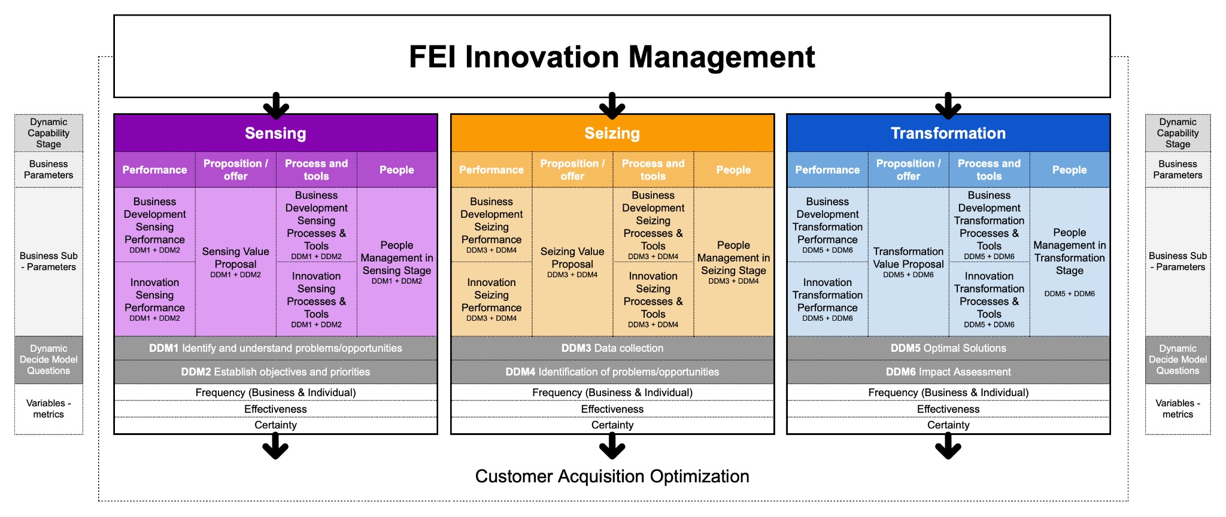The pursuit of understanding how innovation operates within organisations necessitates a comprehensive framework that encapsulates multiple dimensions of organisational processes and capabilities. The proposed five-level model offers a structured approach to dissecting innovation by integrating dynamic capabilities, innovation elements, sub-elements, dynamic capability substages, and key variables of frequency, effectiveness, and certainty (FEC). This model not only aligns theoretical constructs with practical applications but also facilitates empirical analysis through participant responses across specified criteria.

**Level 1: Dynamic Capabilities Stages**

At the macro level, the model adopts David Teece's dynamic capabilities framework, which delineates three critical stages: **Sensing**, **Seizing**, and **Transformation**.These stages serve as the foundational pillars upon which the innovation processes are analysed, emphasising the organisation's ability to adapt and evolve in a dynamic market landscape.

* **Sensing** involves the identification and assessment of opportunities and threats in the business environment.
* **Seizing** refers to the mobilisation of resources to capture data and value from identified opportunities.
* **Transformation** entails the continuous renewal and reconfiguration of organisational assets to maintain competitive advantage.

**Level 2: 4P Innovation Business Parameters**

Embedded within each dynamic capability stage are the four primary innovation business parameters, conceptualised as the **4Ps**:

1. **Performance**: Focused on the outcomes of innovation activities, this element assesses the effectiveness and impact of innovation on organisational success.
2. **Proposition**: This pertains to the value proposition or the unique offerings that result from innovation efforts, directly influencing performance outcomes.
3. **Process & Tools**: Encompassing the methodologies, procedures, and instruments employed, this element facilitates the development of the value proposition.
4. **People**: Centred on the individuals and teams executing the processes, highlighting the role of human capital in driving innovation.

By examining these parameters, the model provides a holistic view of innovation from external outputs (performance) to internal enablers (people).

**Level 3: 4P Innovation Business Sub-parameters**

Each innovation element is further decomposed into sub-elements to capture specific facets:

* **Performance** is divided into:
  + **Business Development**: Activities aimed at expanding market presence and customer base.
  + **Innovation**: Initiatives focused on creating new products, services, or processes.
* **Proposition** includes:
  + **Value Proposition**: The unique value delivered to customers through the organisation's offerings.
* **Process & Tools** comprises:
  + **Business Development Processes**: Procedures for identifying and exploiting market opportunities.
  + **Innovation Processes**: Structured approaches to developing new ideas and solutions.
  + **Use of Tools**: The application of technological and analytical tools to enhance processes.
* **People** encompasses:
  + **Management**: Leadership and managerial practices that influence innovation activities.

This level allows for a granular analysis of the components that contribute to each primary innovation element.

**Level 4: Dynamic Decide Model Questions**

Aligning with the dynamic capabilities stages, the model identifies specific questions (**DDM1** to **DDM6**) to map the progression of innovation activities related to the dynamic decide model.:

* **Sensing**:
  + **DDM1**: *Identify and Understand Problems/Opportunities* – Recognising areas for innovation.
  + **DDM2**: *Establish Objectives and Priorities* – Setting goals for innovation efforts.
* **Seizing**:
  + **DDM3**: *Data Collection* – Gathering relevant information to inform innovation.
  + **DDM4**: *Identification of Problems/Opportunities* – Deepening the understanding of areas to address.
* **Transformation**:
  + **DDM5**: *Optimal Solutions* – Developing the best possible solutions for identified issues.
  + **DDM6**: *Impact Assessment* – Evaluating the effects of implemented innovations.

For each Parameters and sub-paremeters from the 2nd and 3rd level, these questions provide a temporal and procedural context, facilitating a step-by-step examination of innovation decision model activities.

**Level 5: Variables FEC**

The final level introduces the **FEC variables**, which are critical for assessing the execution and perception of innovation activities:

* **2 Frequencies (Business and Individual)**: Measures how often the organisation and its individuals engage in specific innovation activities.
* **Effectiveness (Business)**: Assesses the success rate and outcomes of innovation efforts from an organisational perspective.
* **Certainty (Individual)**: Reflects the confidence and perceived clarity individuals have when performing innovation-related tasks.

These variables enable both quantitative and qualitative analysis of innovation processes, capturing not only the occurrence but also the efficacy and assurance associated with innovation activities.

**Integration and Data Collection**

Participants in the study contribute data corresponding to each level and element of the model. Each participant's responses populate a comprehensive dataset, with each row representing an individual and each column corresponding to specific criteria derived from the levels and elements.

For instance, a participant would provide insights on how frequently their organisation engages in DDM1 activities within the Business Development sub-parameter of Performance during the Sensing stage. They would also rate the effectiveness and certainty associated with these activities.

Similarly, participants assess the utilisation of tools within the Process & Tools element, providing data on the level of tool usage and its impact on innovation processes.

# **A Sensing**

## 

The Sensing stage serves as the foundational bedrock of our integrated five-level model for understanding organisational innovation. It is at this initial juncture that organisations engage in the critical process of identifying and interpreting signals from both their internal operations and the external environment. This stage is paramount because it determines how effectively an organisation can recognise emerging opportunities and threats, which in turn influences its capacity for innovation and sustained competitiveness.

In today's rapidly evolving market landscape, organisations must be adept at perceiving subtle shifts in consumer behaviour, technological advancements, and competitive dynamics. The Sensing stage encapsulates this necessity, emphasising the importance of vigilance and proactive engagement with the surrounding environment. It is not merely about collecting data but about cultivating the ability to discern meaningful patterns and insights that can inform strategic decision-making.

Our exploration of the Sensing stage delves into several interconnected dimensions of the model to provide a comprehensive understanding of how organisations navigate this phase.

Firstly, we consider the concept of dynamic capabilities, as articulated by David Teece. Within this framework, Sensing is recognised as a vital capability that enables organisations to adapt and thrive amidst change. It involves processes that allow firms to scan, search, and explore across technologies and markets, both local and distant. Organisations with strong sensing capabilities are better positioned to anticipate shifts, identify unmet customer needs, and spot technological possibilities ahead of competitors.

Moving into the realm of the 4P innovation business parameters—Performance, Proposition, Process & Tools, and People—we examine how each aspect plays a role during the Sensing stage.

**Performance** focuses on how organisations assess their current achievements and shortcomings to pinpoint areas ripe for innovation. During the Sensing stage, businesses scrutinise metrics related to revenue growth, customer acquisition, and market share. This analysis helps them to identify performance gaps and emerging opportunities in business development and innovation outputs.

Under **Proposition**, the emphasis is on understanding and refining the value proposition. Organisations must remain acutely aware of evolving customer needs and preferences. By actively seeking feedback and monitoring market trends, they can adjust their offerings to ensure they remain relevant and compelling. This continual reassessment of the value proposition is essential for maintaining a competitive edge.

The **Process & Tools** parameter examines the methodologies and instruments organisations employ to facilitate effective sensing. This includes leveraging advanced market research techniques, data analytics, and predictive modelling. The sophistication and efficiency of these processes significantly influence an organisation's ability to generate valuable insights during the Sensing stage.

The role of **People**—particularly leadership and management teams—is crucial. Effective sensing relies on a culture that encourages curiosity, open communication, and continuous learning. Leaders must foster an environment where team members feel empowered to share observations, challenge assumptions, and explore new ideas. This collaborative atmosphere enhances the organisation's collective ability to sense and interpret changes in the environment.

Delving deeper, we explore specific sub-parameters within these categories. For instance, in **Business Development Performance**, we assess how organisations pursue strategies for revenue growth and customer acquisition during the Sensing stage. This involves evaluating efforts in market expansion and the identification of new opportunities for growth.

In the context of **Innovation Performance**, we consider how organisations recognise potential for new products or services. This includes allocating resources for research and development initiatives and understanding shifts in intellectual property landscapes. Recognising these opportunities early can position an organisation as a market leader rather than a follower.

When examining the **Value Proposition**, we focus on how businesses identify customer pain points and unmet needs. This involves not just reacting to customer feedback but anticipating future desires and market trends. By doing so, organisations can craft offerings that resonate deeply with their target audiences.

The **Process Improvements** sub-parameter involves analysing existing business development and innovation processes to identify areas for enhancement. Organisations must be willing to question established procedures and adopt new technologies or methodologies that can improve efficiency and effectiveness.

In considering **Management Practices**, we reflect on how leadership approaches influence the Sensing stage. This includes setting clear objectives and priorities that align with the insights gained during sensing activities. Leaders play a pivotal role in ensuring that the organisation remains agile and responsive to new information.

Central to our analysis are the **Dynamic Decide Model Questions**, particularly:

* **Identify and Understand Problems/Opportunities (DDM1):** This question probes how adept organisations are at detecting challenges and recognising opportunities within the market. It involves understanding customer acquisition dynamics, market share fluctuations, and the competitive landscape.
* **Establish Objectives and Priorities (DDM2):** Here, we assess how effectively organisations set clear goals and priorities based on the insights garnered. Aligning strategic objectives with identified opportunities ensures that efforts and resources are directed towards areas with the greatest potential impact.

To provide a nuanced understanding of the Sensing stage, we incorporate the variables of **Frequency, Effectiveness, and Certainty (FEC)**. These variables offer a lens through which to gauge the depth and quality of sensing activities.

* **Frequency** examines how regularly organisations and individuals engage in sensing activities. Regular engagement indicates a proactive approach to staying informed and adaptable.
* **Effectiveness** assesses the success rate of these activities in yielding actionable insights. High effectiveness suggests that the organisation not only gathers information but also interprets it meaningfully.
* **Certainty** reflects the confidence levels of individuals when interpreting and acting upon the information gathered. A high level of certainty can enhance decision-making speed and accuracy, though it must be balanced with openness to new data and perspectives.

In conclusion, the Sensing stage is about much more than data collection; it is about developing a keen awareness of the complex interplay of factors that influence markets and industries. Organisations that excel in sensing are better equipped to innovate effectively, maintain competitiveness, and achieve long-term succes.

## 1 A Sensing / P1.1 Performance + Business Development / DM1 - DM2

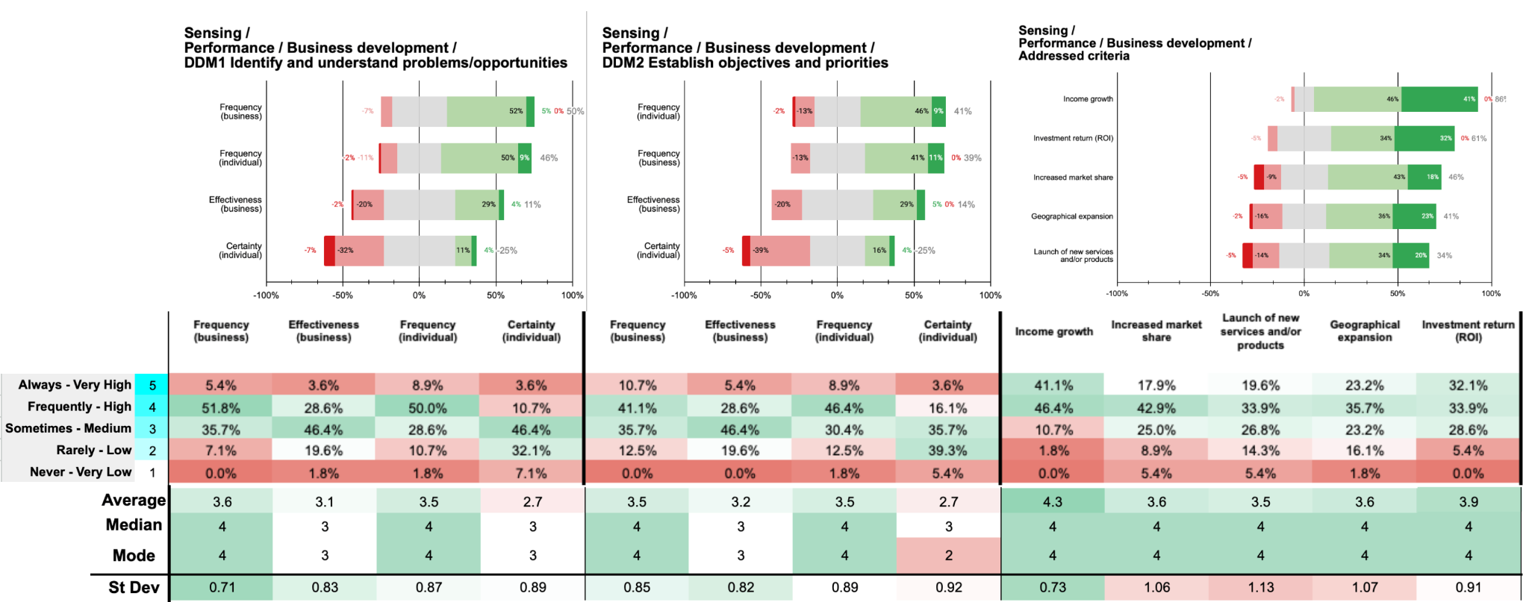

In the sensing stage of dynamic capabilities, focusing on performance in business development, the data reveals that a majority of participants perceive their organisations as *frequently* or *always* engaging in key activities. For DDM1, which involves identifying and understanding problems or opportunities, 57.2% of participants believe their organisation undertakes this activity *always* or *frequently*. At the individual level, 58.9% *always* or *frequently* participate in these processes. Similarly, for DDM2, concerning establishing objectives and priorities, 51.8% indicate that their organisation engages in this *always* or *frequently*, with 55.3% of individuals participating at the same frequency. This suggests a consistent level of engagement in critical business development activities both organisationally and individually during the sensing stage.

However, when considering effectiveness and individual certainty, there appears to be a notable disparity. Only 32.2% of participants rate their organisation's effectiveness in DDM1 as *high* or *very high*, and a similar 34.0% do so for DDM2. Individual certainty is also relatively low, with just 14.3% experiencing a *high* or *very high* level of certainty in DDM1, and 19.7% in DDM2. This gap between the frequency of engagement and the perceived effectiveness and certainty suggests potential deficiencies in how these activities are executed or communicated within organisations, possibly indicating a need for improved processes or clearer guidance.

When examining the specific criteria addressed during these practices, the combined *always* and *frequently* responses indicate that income growth (87.5%) and investment return (ROI) (66.0%) are the most prioritised factors. In contrast, the launch of new services and/or products is prioritised by only 53.5% of participants. This pattern implies that organisations are more focused on immediate financial outcomes rather than on innovation and product development. Such an emphasis on short-term financial metrics may limit long-term strategic innovation, potentially hindering future competitiveness and adaptability in a dynamic market environment.

**Main findings / insights:**

1. **High Engagement in Identifying Opportunities**: Over half of participants (57.2%) report their organisation frequently engages in identifying business development opportunities, with a similar level of individual participation (58.9%).
2. **Effectiveness and Certainty Lag Behind Engagement**: Despite frequent involvement, only about a third perceive organisational effectiveness as high (32.2% for DDM1), and individual certainty remains low, with only 14.3% experiencing high levels.
3. **Focus on Short-Term Financial Gains**: Organisations prioritise income growth (87.5%) and ROI (66.0%) over launching new products (53.5%), indicating a preference for immediate financial outcomes over long-term innovation.

## 2 A Sensing / P1.2 Performance + Innovation / DM1 - DM2

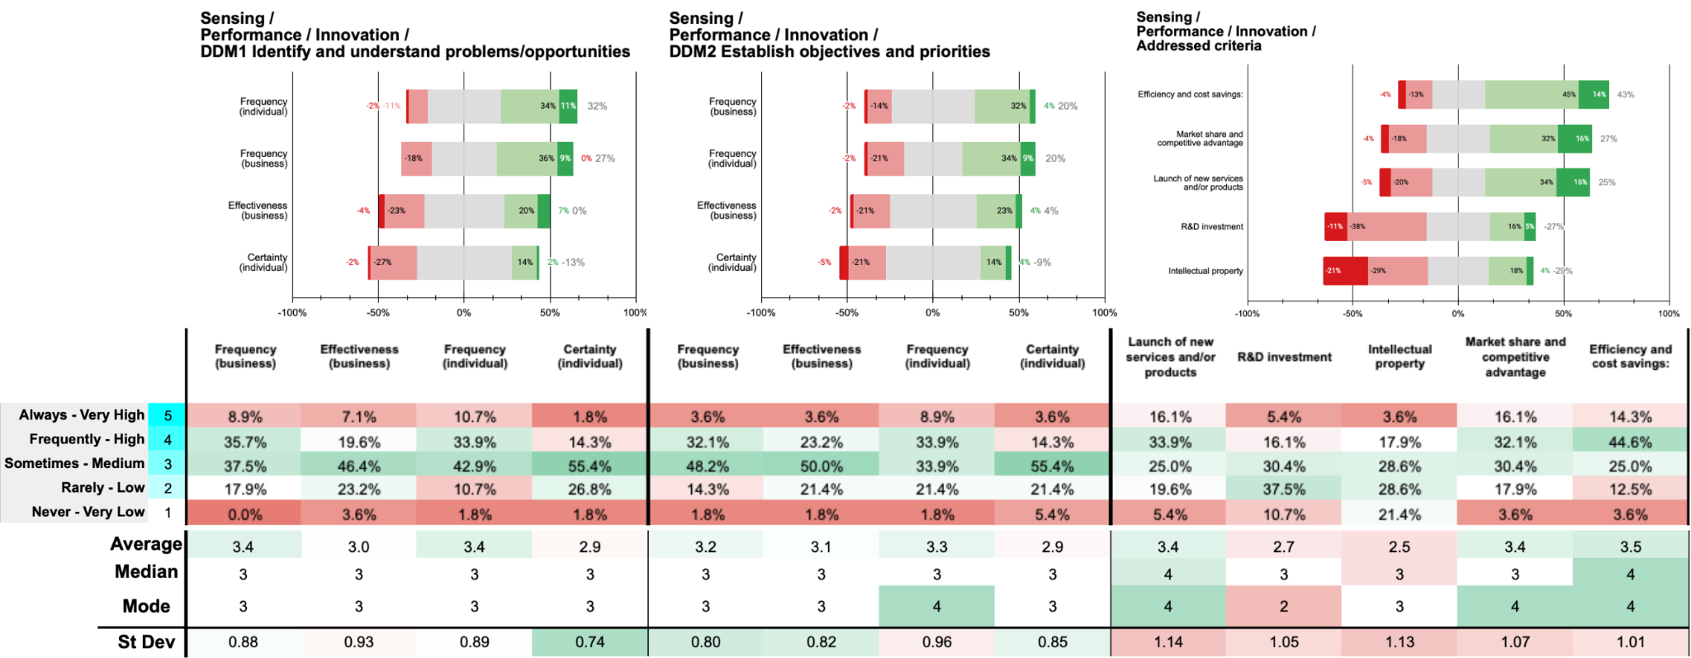

During the sensing stage of dynamic capabilities, focusing on performance in innovation, the data reveals moderate engagement in identifying and understanding problems or opportunities (DDM1) and establishing objectives and priorities (DDM2). For DDM1, 44.6% of participants perceive their organisation *always* or *frequently* identifies innovation problems to boost customer acquisition (8.9% *always*, 35.7% *frequently*). At the individual level, 44.6% *always* or *frequently* participate in these activities (10.7% *always*, 33.9% *frequently*). In DDM2, 35.7% believe their organisation engages in establishing clear objectives *always* or *frequently* (3.6% *always*, 32.1% *frequently*), while 42.8% of individuals participate at these frequencies (8.9% *always*, 33.9% *frequently*). This suggests individual involvement slightly exceeds organisational emphasis in innovation activities during the sensing stage.

Perceived effectiveness and individual certainty are modest. Only 26.7% rate their organisation's effectiveness in DDM1 as *high* or *very high* (7.1% *very high*, 19.6% *high*), with a similar 26.8% for DDM2 (3.6% *very high*, 23.2% *high*). Individual certainty is relatively low, with just 16.1% experiencing *high* or *very high* certainty in DDM1 (1.8% *very high*, 14.3% *high*) and 17.9% in DDM2. This disparity indicates that while individuals are engaged, they may lack confidence in their roles or in outcomes, possibly due to insufficient organisational support.

When examining the criteria addressed during the establishment of priorities and objectives for the value proposition, efficiency and cost savings emerge as the most prioritised criterion, with 58.9% indicating their organisation *always* or *frequently* addresses it (14.3% *always*, 44.6% *frequently*). Market share and competitive advantage follow at 48.2% (16.1% *always*, 32.1% *frequently*). In contrast, R&D investment and intellectual property receive less emphasis, each with only 21.5% indicating these are *always* or *frequently* addressed. The launch of new services and/or products is prioritised by 50.0% (16.1% *always*, 33.9% *frequently*). This pattern suggests organisations focus more on operational efficiencies and maintaining competitive positions rather than investing in innovation drivers like R&D and intellectual property, potentially limiting long-term innovation capabilities.

**Main findings / insights:**

1. **Moderate Organisational Engagement in Innovation Identification**: Just 44.6% report frequent organisational efforts in identifying innovation problems for customer acquisition, with a similar level of individual involvement, indicating a balanced yet moderate engagement.
2. **Low Effectiveness and Confidence**: Only around a quarter of participants view the organisation’s effectiveness as high in both innovation problem identification (26.7%) and objective setting (26.8%), while individual certainty remains notably low.
3. **Prioritisation of Efficiency Over Innovation Drivers**: Organisations focus more on efficiency and cost savings (58.9%) and competitive positioning (48.2%), while R&D investment (21.5%) and intellectual property remain less emphasised, potentially limiting long-term innovation prospects.

## 3 A Sensing / P2.1 Offer + Value proposal / DM1 - DM2

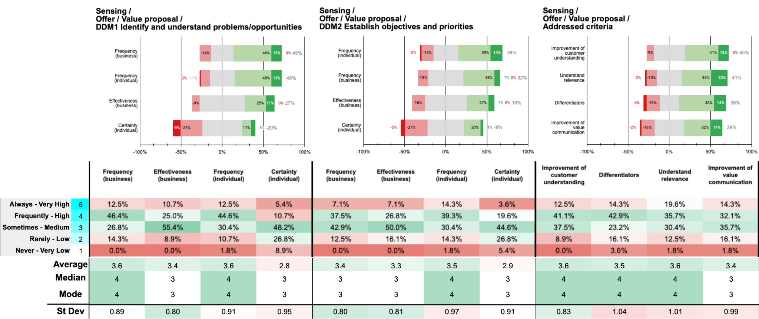

For DDM1, a combined 58.9% of participants indicate that their organisations *always* or *frequently* identify and define value propositions for customer acquisition (12.5% *always*, 46.4% *frequently*). Individual participation mirrors this, with 57.1% *always* or *frequently* involved (12.5% *always*, 44.6% *frequently*). However, only 35.7% perceive their organisations' effectiveness in this area as *high* or *very high* (10.7% *very high*, 25.0% *high*), and merely 16.1% experience a *high* or *very high* level of certainty individually (5.4% *very high*, 10.7% *high*). This suggests that despite significant engagement, there is a discrepancy in perceived effectiveness and individual confidence. In DDM2, which involves establishing clear objectives and priorities for adapted value propositions, organisational engagement is reported as *always* or *frequently* by 44.6% of participants (7.1% *always*, 37.5% *frequently*). Individual participation is slightly higher, with 53.6% indicating they *always* or *frequently* partake (14.3% *always*, 39.3% *frequently*). Perceived organisational effectiveness remains modest, with only 33.9% rating it as *high* or *very high* (7.1% *very high*, 26.8% *high*), and individual certainty is reported as *high* or *very high* by just 23.2% (3.6% *very high*, 19.6% *high*). The persistent gap between engagement and both effectiveness and certainty indicates potential issues with clarity of objectives, communication, or resource allocation within organisations during this stage.

Examining the addressed criteria during the establishment of value proposition priorities reveals that Differentiators (unique selling points; differentiating products/services) are the most prioritised, with 57.2% indicating their organisations *always* or *frequently* address this . Improvement of customer understanding follows closely at 53.6%, and Understanding relevance (market trends; industry challenges) at 55.3%. Improvement of value communication is somewhat less emphasised, with 46.4% addressing it *always* or *frequently*. These findings suggest that organisations recognise the importance of differentiating their offerings and understanding customer needs, yet may be underemphasising effective communication of value propositions.

**Main findings / insights:**

1. **Significant Engagement with Value Proposition Identification**: A strong majority (58.9%) report that their organisations frequently engage in identifying value propositions for customer acquisition, though effectiveness in this area remains comparatively low at 35.7%.
2. **Discrepancy in Effectiveness and Confidence**: While individual involvement is high, only 16.1% of participants feel a high level of certainty in defining value propositions, highlighting a gap between participation and confidence.
3. **Focus on Differentiation Over Communication**: Organisations prioritise differentiators (57.2%) and customer understanding (53.6%) when setting value proposal priorities, yet value communication receives less emphasis, potentially impacting the clarity of messaging to customers.

## 4 A Sensing / P3.1 Process + Business Development / DM1 - DM2

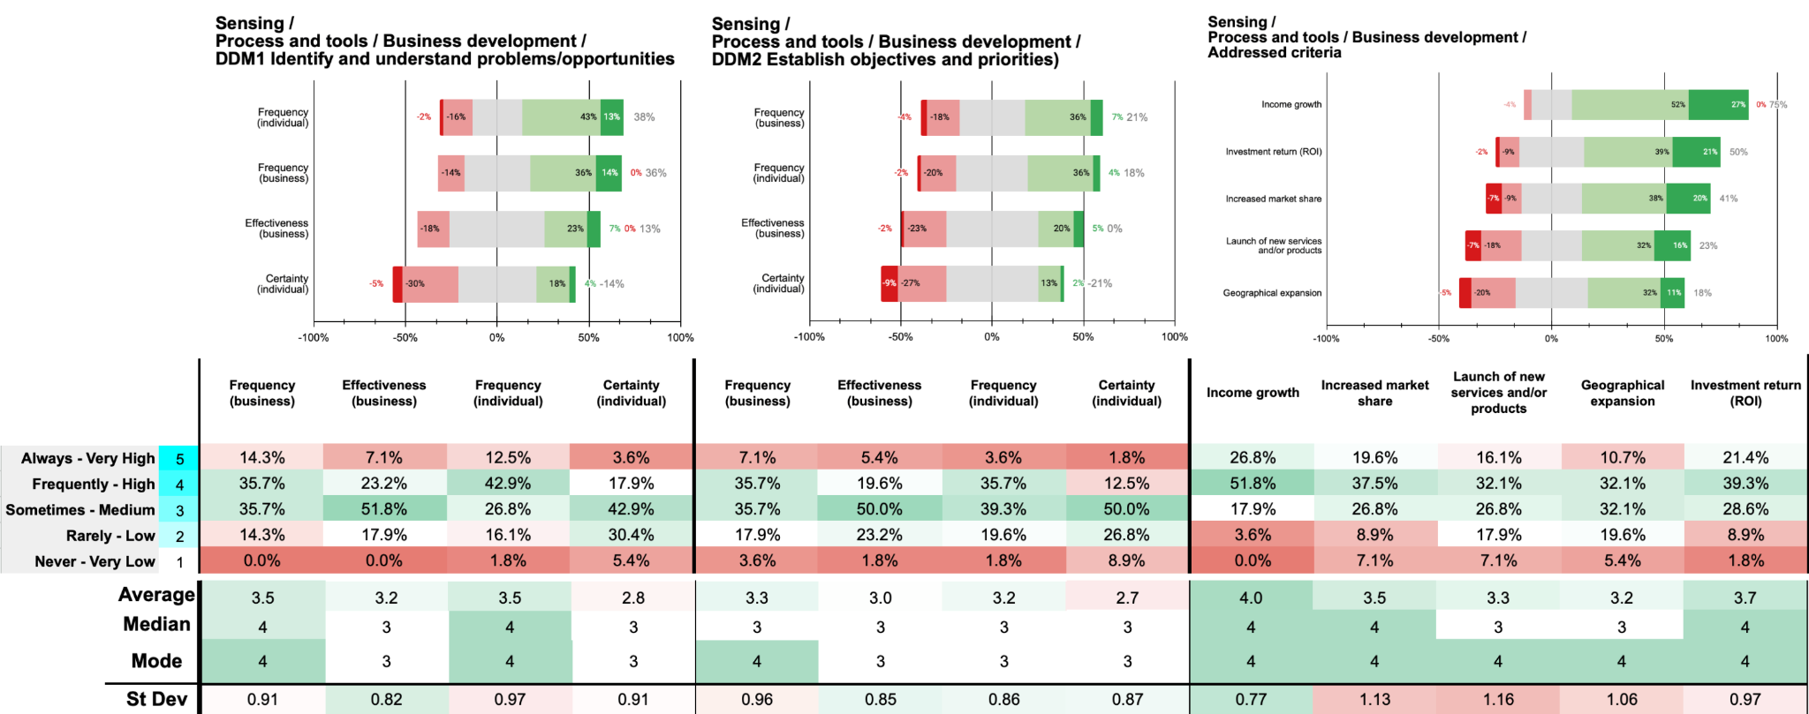

For DDM1, 50% of participants perceive that their organisations *always* or *frequently* identify and define process problems or improvements to reinforce customer acquisition (14.3% *always*, 35.7% *frequently*). Individual participation is higher, with 55.4% *always* or *frequently* involved (12.5% *always*, 42.9% *frequently*). However, only 30.3% rate their organisations' effectiveness as *high* or *very high* (7.1% *very high*, 23.2% *high*), and merely 21.5% experience a *high* or *very high* level of certainty in their roles (3.6% *very high*, 17.9% *high*). This suggests a discrepancy between high participation and lower perceived effectiveness and confidence during process improvement identification.

Regarding DDM2, which involves establishing clear business development practices for customer acquisition, organisational engagement remains consistent, with 42.8% indicating their organisations *always* or *frequently* undertake this (7.1% *always*, 35.7% *frequently*). Individual involvement is slightly lower, with 39.3% *always* or *frequently participating* (3.6% *always*, 35.7% *frequently*). Perceived organisational effectiveness is modest, with only 25% rating it as *high* or *very high* (5.4% *very high*, 19.6% *high*), and individual certainty is low, with just 14.3% experiencing a *high* or *very high* level of certainty (1.8% *very high*, 12.5% *high*). The consistent gap between engagement and both effectiveness and certainty highlights potential issues in communication and implementation of business development practices.

When examining the addressed criteria for refining business development processes, income growth is the most prioritised, with 78.6% indicating their organisations *always* or *frequently* address it (26.8% *always*, 51.8% *frequently*). Investment return (ROI) follows at 60.7% (21.4% *always*, 39.3% *frequently*), and increased market share at 57.1% (19.6% *always*, 37.5% *frequently*). Lower prioritisation is given to the launch of new services and/or products (48.2%) and geographical expansion (42.8%), suggesting a focus on optimising existing offerings over pursuing innovation or expansion.

In summary, while there is substantial engagement in refining business development processes during the sensing stage, perceived effectiveness and individual certainty do not align with participation levels. Enhancing communication, providing clearer frameworks, and investing in training could improve both the effectiveness of process improvements and employee confidence. Addressing these gaps may enable organisations to better leverage their dynamic capabilities, optimising business development processes to maximise customer acquisition and strengthen competitive positioning.

**Main findings / insights:**

1. **High Engagement with Process Improvement Identification**: Half of the participants report frequent organisational engagement in identifying process improvements for customer acquisition, with even higher individual involvement at 55.4%, though effectiveness ratings remain modest at 30.3%.
2. **Gap in Certainty and Organisational Effectiveness**: Despite substantial participation, only 21.5% of individuals report high certainty in their roles, indicating a need for clearer guidance and enhanced confidence-building within the organisation.
3. **Prioritisation of Financial Metrics Over Innovation**: Organisations consistently prioritise income growth (78.6%) and ROI (60.7%) in business development processes, while factors like new product launches receive comparatively less focus, suggesting a short-term financial emphasis.

## 5 A Sensing / P3.2 Process + Innovation / DM1 - DM2

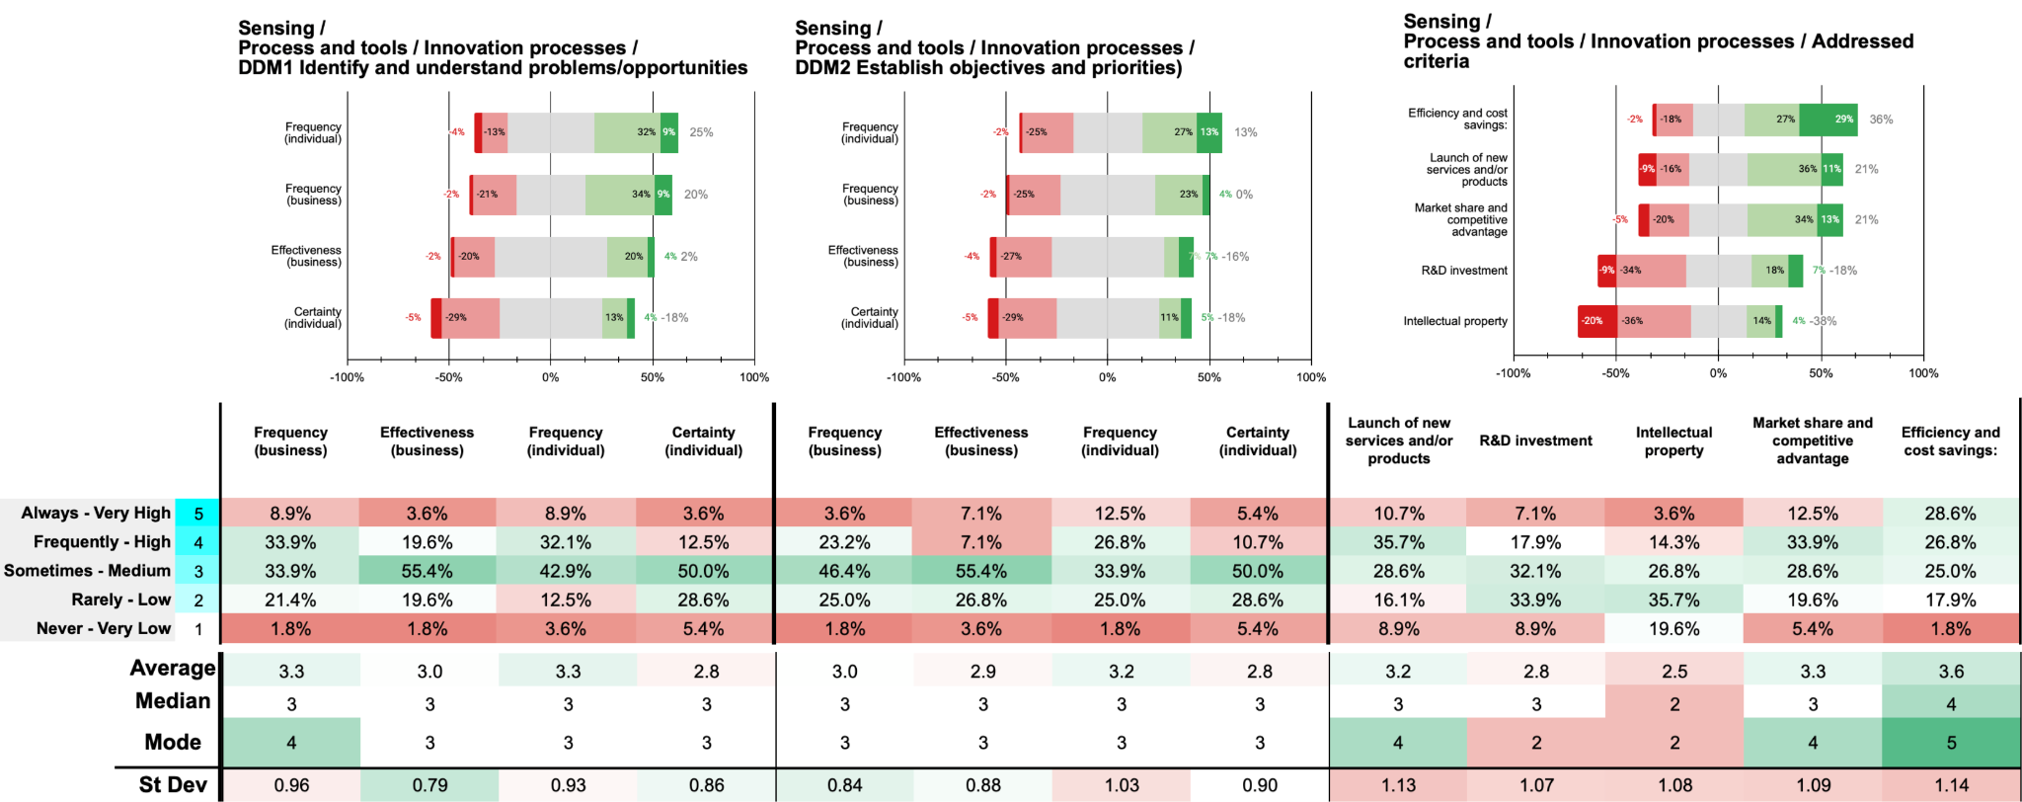

For DDM1, 42.8% of participants perceive that their organisations *always* or *frequently* identify and define process problems or improvements in their innovation processes to boost customer acquisition (8.9% *always*, 33.9% *frequently*). Individual participation is similar, with 41.0% *always* or *frequently* involved (8.9% *always*, 32.1% *frequently*). However, only 23.2% rate their organisations' effectiveness as *high* or *very high* (3.6% *very high*, 19.6% *high*), and merely 16.1% experience a *high* or *very high* level of certainty in their roles (3.6% *very high*, 12.5% *high*). This suggests a discrepancy between engagement levels and both perceived organisational effectiveness and individual confidence during the identification of innovation process improvements.

Regarding DDM2, which involves establishing clear innovation practices focused on improving customer acquisition, organisational engagement increases, with 50.0% indicating their organisations *always* or *frequently* undertake this (3.6% *always*, 46.4% *frequently*). Individual participation is slightly higher, with 39.3% *always* or *frequently* participating (12.5% *always*, 26.8% *frequently*). Perceived organisational effectiveness remains modest, with only 14.2% rating it as *high* or *very high* (7.1% *very high*, 7.1% *high*), and individual certainty is low, with just 16.1% experiencing a *high* or *very high* level of certainty (5.4% *very high*, 10.7% *high*). The consistent gap between engagement and both effectiveness and certainty highlights potential issues in how organisations implement and communicate innovation practices.

Examining the addressed criteria, Efficiency and cost savings is the most prioritised, with 55.4% indicating it is *always* or *frequently* addressed. Market share and competitive advantage follows at 46.4%. In contrast, R&D investment and Intellectual property receive less emphasis, at 25.0% and 17.9% respectively. These findings suggest organisations focus more on immediate operational efficiencies than on long-term innovation drivers, potentially limiting future competitiveness.

**Main findings / insights:**

1. **Moderate Engagement with Innovation Process Improvement**: 42.8% of participants report frequent organisational involvement in identifying innovation process improvements, with a slightly lower individual participation rate at 41.0%, highlighting moderate but consistent engagement.
2. **Low Effectiveness and Individual Confidence Levels**: Despite frequent engagement, only 23.2% rate organisational effectiveness as high, and individual confidence is similarly low at 16.1%, suggesting potential gaps in guidance and support for innovation-related process improvements.
3. **Emphasis on Efficiency Over Innovation Investment**: Efficiency and cost savings (55.4%) are prioritised over R&D investment (25.0%) and Intellectual Property (17.9%), indicating a focus on operational gains over foundational innovation, potentially constraining future growth and competitiveness.

## 6 A Sensing / P3.3 Process + Tools / Use of tools

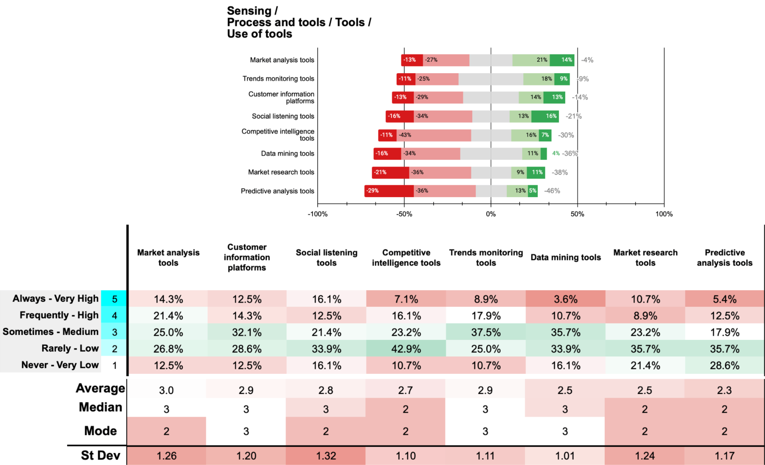

The tools most frequently rated as being used at a very high or high level are Market Analysis Tools (35.7% combined: 14.3% very high, 21.4% high) and Customer Information Platforms (26.8% combined: 12.5% very high, 14.3% high). Social Listening Tools also show notable usage, with 28.6% indicating very high or high use (16.1% very high, 12.5% high). This suggests that organisations place significant emphasis on tools that provide immediate insights into market trends and customer behaviours.

Conversely, advanced analytical tools such as Predictive Analysis Tools and Data Mining Tools exhibit lower levels of high usage. Only 17.9% report very high or high use of predictive analysis tools (5.4% very high, 12.5% high), and a mere 14.3% indicate similar usage levels for data mining tools (3.6% very high, 10.7% high). Notably, predictive analysis tools have the highest percentage of very low usage at 28.6%, suggesting limited adoption within the surveyed organisations.

Trends Monitoring Tools show moderate utilisation, with 26.8% indicating very high or high use (8.9% very high, 17.9% high), but also a significant portion reporting medium (37.5%) and low (25.0%) usage levels. Competitive Intelligence Tools are less utilised, with 23.2% reporting very high or high use (7.1% very high, 16.1% high), and 10.7% indicating very low usage.

These patterns suggest that organisations may prioritise tools that offer direct insights into current market conditions and customer data over more sophisticated tools requiring advanced analytical capabilities. The lower adoption of tools like predictive analytics and data mining could be attributed to factors such as resource limitations, lack of technical expertise, or perceived complexity and cost of implementation.

**Main findings / insights:**

1. **High Utilisation of Market and Customer Insight Tools**: Tools focused on market analysis (35.7%) and customer information platforms (26.8%) are the most frequently used at high levels, highlighting a prioritisation of tools that deliver immediate insights into market trends and customer behaviours.
2. **Lower Adoption of Advanced Analytical Tools**: Predictive analysis and data mining tools show limited high usage (17.9% and 14.3%, respectively), with predictive analysis tools notably exhibiting the highest rate of very low usage at 28.6%, suggesting challenges in adopting sophisticated analytics capabilities.
3. **Focus on Operational Efficiency Over Long-Term Competitiveness**: Efficiency-oriented tools, such as social listening (28.6%) and trends monitoring tools (26.8%), are prioritised over strategic tools like competitive intelligence (23.2%) and R&D, indicating a focus on immediate insights rather than developing long-term competitive advantages.

## 7 A Sensing / P4.1 People + Management / DM1 - DM2

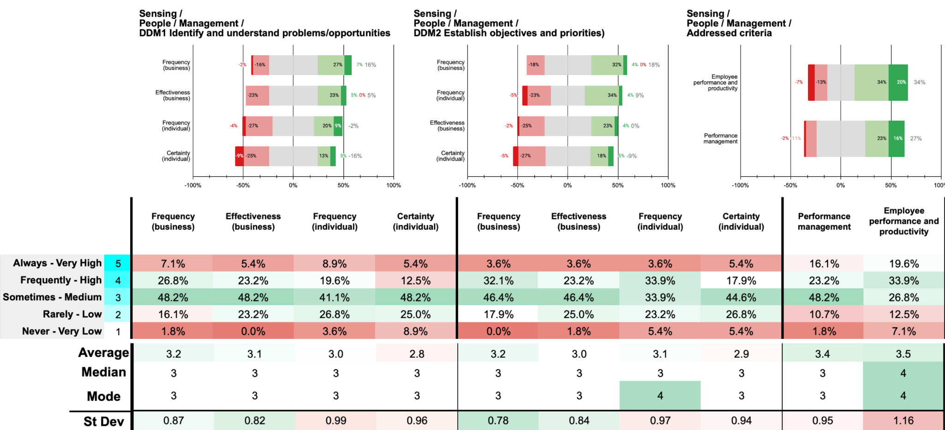

For DDM1, 33.9% of participants report that their organisations *always* or *frequently* identify and define relevant management needs for customer acquisition (7.1% *always*, 26.8% *frequently*). Individual participation is slightly lower, with 28.5% *always* or *frequently* involved (8.9% *always*, 19.6% *frequently*). However, only 28.6% perceive their organisations' effectiveness in this area as *high* or *very high* (5.4% *very high*, 23.2% *high*), and just 17.9% feel a *high* or *very high* level of certainty in their roles (5.4% *very high*, 12.5% *high*). This suggests a gap between organisational efforts and both perceived effectiveness and individual confidence during the identification of management needs.

In DDM2, which involves establishing management objectives and priorities focused on customer acquisition, organisational engagement slightly improves, with 35.7% indicating their organisations *always* or *frequently* undertake this (3.6% *always*, 32.1% *frequently*). Individual participation is higher, with 37.5% *always* or *frequently* involved (3.6% *always*, 33.9% *frequently*). Despite this, only 26.8% rate their organisations' effectiveness as *high* or *very high* (3.6% *very high*, 23.2% *high*), and a modest 23.3% experience a *high* or *very high* level of certainty (5.4% *very high*, 17.9% *high*). The persistent disparity between engagement and both effectiveness and certainty indicates potential issues in communication or resource allocation within management practices.

When examining the addressed criteria, Employee Performance and Productivity is prioritised slightly more than Performance Management, with 53.5% of participants indicating their organisations *always* or *frequently* address it (19.6% *always*, 33.9% *frequently*), compared to 39.3% for Performance Management (16.1% *always*, 23.2% *frequently*). This suggests a focus on individual employee outputs over systemic performance management processes.

**Main findings / insights:**

1. **Low Organisational Engagement in Identifying Management Needs**: Only 33.9% of participants report that their organisations frequently identify and define management needs for customer acquisition, with individual participation slightly lower at 28.5%.
2. **Perceived Effectiveness and Confidence are Limited**: Despite some engagement, merely 28.6% perceive organisational effectiveness as high, and only 17.9% feel a high level of certainty in their roles, indicating potential issues in communication or support within management practices.
3. **Emphasis on Individual Performance over Management Systems**: Organisations prioritise employee performance and productivity (53.5%) more than systemic performance management (39.3%), suggesting a focus on individual outputs rather than structured management processes.

## Analysis of the Sensing Stage in Organisational Innovation

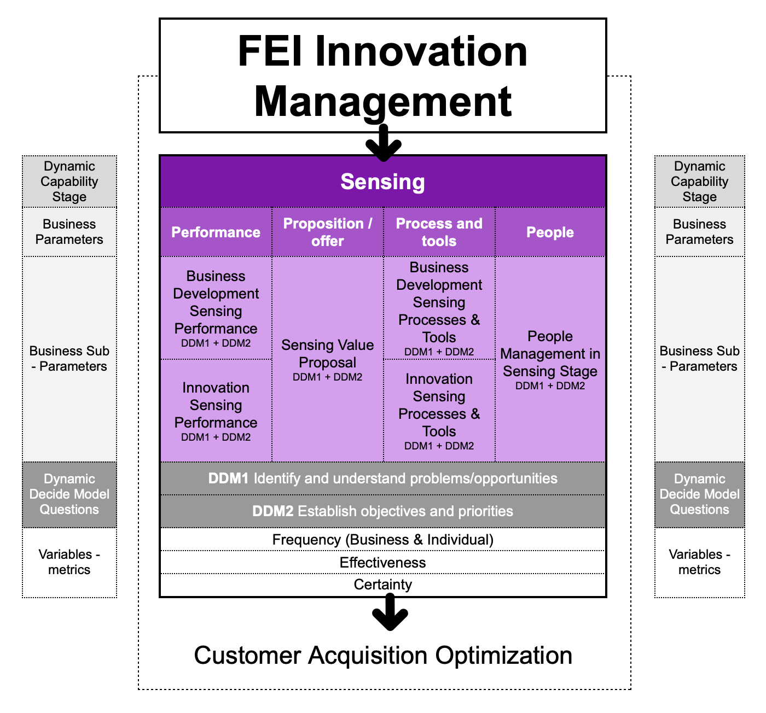

**Engagement in Identifying Opportunities and Challenges**

The data indicates that a majority of organisations exhibit substantial engagement in key sensing activities related to business development. Specifically, 57.2% of participants report that their organisations always or frequently engage in identifying and understanding problems or opportunities (DDM1). At the individual level, this engagement is slightly higher, with 58.9% of respondents participating in these activities with the same frequency. This alignment between organisational and individual engagement suggests a concerted effort towards recognising areas for improvement or growth.

In establishing objectives and priorities (DDM2), the trend continues, albeit with a slight decrease. Here, 51.8% of participants indicate that their organisations always or frequently undertake this activity, while individual participation stands at 55.3%. The consistent involvement at both organisational and individual levels underscores the recognised importance of setting clear goals to guide business development initiatives during the sensing stage.

**Disparity in Effectiveness and Certainty**

Despite the high levels of engagement, there is a notable disparity when it comes to perceived effectiveness and individual certainty. Only 32.2% of participants rate their organisation's effectiveness in DDM1 as high or very high. A similar figure is observed for DDM2, with just 34.0% perceiving high or very high effectiveness. Individual certainty is even lower, with only 14.3% experiencing a high or very high level of certainty in DDM1 and 19.7% in DDM2.

This gap between engagement and effectiveness suggests potential deficiencies in how these activities are executed or communicated within organisations. The low levels of individual certainty might indicate that employees are unclear about their roles, the objectives of the activities, or the expected outcomes. It may also reflect insufficient support or resources provided to staff to carry out these tasks effectively.

**Prioritisation of Business Development Criteria**

When examining the specific criteria addressed during the establishment of priorities and objectives, a clear pattern emerges. Income growth is overwhelmingly prioritised, with 87.5% of participants indicating that their organisations always or frequently focus on this factor. Investment return (ROI) is also highly emphasised, with 66.0% prioritising it. In contrast, the launch of new services or products is a priority for only 53.5% of organisations, and geographical expansion is even less emphasised.

This pattern suggests that organisations are predominantly focused on immediate financial outcomes rather than on innovation or expansion into new markets. While financial performance is undeniably crucial, an overemphasis on short-term metrics may limit an organisation's ability to innovate and adapt in the long term. By not prioritising the development of new products or services, organisations risk stagnation and may be less competitive in dynamic market environments.

**Engagement in Innovation Activities**

In the context of innovation performance during the sensing stage, the data reveals moderate engagement levels. For DDM1, 44.6% of participants perceive that their organisations always or frequently identify innovation problems to boost customer acquisition. Individual participation mirrors this, with 44.6% always or frequently involved in such activities. However, the perceived organisational effectiveness in identifying and understanding innovation problems is modest, with only 26.7% rating it as high or very high. Individual certainty is also low, at 16.1%.

When it comes to establishing objectives and priorities for innovation (DDM2), organisational engagement decreases to 35.7%, though individual participation remains relatively steady at 42.8%. The low levels of perceived effectiveness and certainty in innovation activities suggest that, while organisations recognise the importance of innovation, they may lack effective strategies or sufficient support to execute these activities successfully.

**Focus on Operational Efficiencies Over Innovation Drivers**

The criteria prioritised during the establishment of innovation objectives further illustrate the organisational focus. Efficiency and cost savings emerge as the most prioritised criterion, with 58.9% of participants indicating their organisations always or frequently address it. Market share and competitive advantage follow at 48.2%. In stark contrast, R&D investment and intellectual property are prioritised by only 21.5% of organisations.

This emphasis on operational efficiencies and competitive positioning over foundational innovation drivers like R&D and intellectual property development indicates a short-term approach to innovation. While improving efficiency can lead to immediate cost savings and enhanced competitiveness, neglecting investment in R&D and intellectual property may undermine an organisation's capacity for groundbreaking innovation and sustained long-term growth.

**Value Proposition Development**

The development of value propositions is a critical aspect of the sensing stage, as it directly impacts customer acquisition and retention. The data shows that 58.9% of organisations always or frequently engage in identifying and defining value propositions (DDM1). Individual participation is similarly high, at 57.1%. However, perceived organisational effectiveness is relatively low, with only 35.7% rating it as high or very high. Individual certainty is even lower, at 16.1%.

In establishing clear objectives and priorities for adapted value propositions (DDM2), organisational engagement drops to 44.6%, while individual participation remains higher at 53.6%. The persistent gap between engagement and perceived effectiveness and certainty suggests potential issues in how organisations approach value proposition development. These may include unclear objectives, inadequate communication, or insufficient resources dedicated to these activities.

When assessing the specific criteria addressed during value proposition development, organisations prioritise differentiators (unique selling points) the most, with 57.2% always or frequently focusing on this aspect. Improvement of customer understanding and understanding market relevance are also significantly prioritised, at 53.6% and 55.3%, respectively. However, the improvement of value communication is less emphasised, with only 46.4% always or frequently addressing it. This suggests that while organisations recognise the importance of differentiating their offerings and understanding their customers, they may be less effective in communicating this value to the market.

**Process Improvement in Business Development and Innovation**

The identification and refinement of processes are essential for enhancing organisational efficiency and effectiveness. In business development processes (DDM1), 50% of participants report that their organisations always or frequently identify and define process problems or improvements. Individual participation is slightly higher, at 55.4%. Despite this engagement, only 30.3% perceive their organisations' effectiveness in this area as high or very high, and individual certainty is low, at 21.5%.

Similarly, in innovation processes, engagement in identifying process problems or improvements is moderate, with 42.8% of organisations always or frequently involved. However, perceived effectiveness is low, at 23.2%, and individual certainty is even lower, at 16.1%. These figures indicate that while organisations are engaging in process improvement activities, they may lack the necessary frameworks, tools, or support to do so effectively.

When it comes to the criteria prioritised during process refinement, income growth remains the most emphasised factor in business development, addressed by 78.6% of organisations. In innovation processes, efficiency and cost savings are the top priority, addressed by 55.4%. This further underscores the organisational focus on immediate financial outcomes and operational efficiencies over strategic innovation initiatives.

**Use of Tools During the Sensing Stage**

The utilisation of analytical tools is crucial for effective sensing, as they enable organisations to gather and interpret data to inform decision-making. The data reveals that organisations prioritise tools that provide immediate insights into market trends and customer behaviours. Market analysis tools and customer information platforms are among the most frequently used, with 35.7% and 26.8% of participants reporting very high or high levels of usage, respectively.

Conversely, advanced analytical tools such as predictive analysis and data mining tools are less utilised. Only 17.9% report very high or high use of predictive analysis tools, and 14.3% for data mining tools. Notably, predictive analysis tools have the highest percentage of very low usage, at 28.6%. This limited adoption may be due to factors such as resource constraints, lack of technical expertise, or perceived complexity.

The underutilisation of advanced tools suggests that organisations may not be fully leveraging data-driven insights to enhance their sensing capabilities. By relying primarily on basic analytical tools, they may miss deeper trends and patterns that could inform more effective innovation strategies.

**Management Practices and Employee Confidence**

Effective management practices are essential for fostering an environment conducive to innovation. The data indicates that organisational engagement in identifying and defining relevant management needs for customer acquisition is relatively low, with only 33.9% always or frequently engaging in this activity. Individual participation is even lower, at 28.5%. Perceived organisational effectiveness is modest, at 28.6%, and individual certainty is low, at 17.9%.

When establishing management objectives and priorities focused on customer acquisition (DDM2), organisational engagement slightly improves to 35.7%, and individual participation increases to 37.5%. Despite this, perceived effectiveness and certainty remain low. This suggests potential issues in communication, leadership, or resource allocation within management practices.

The criteria prioritised within management practices further highlight organisational focus areas. Employee performance and productivity are prioritised slightly more than performance management, at 53.5% versus 39.3%. This indicates a greater emphasis on individual outputs rather than on systemic processes that could enhance overall organisational performance.

**Conclusions**

The analysis of the sensing stage reveals that while organisations are actively engaged in identifying opportunities and setting objectives, there are significant gaps in perceived effectiveness and individual certainty. The predominant focus on short-term financial metrics, such as income growth and ROI, suggests that organisations may prioritise immediate gains over long-term strategic innovation.

The low levels of perceived effectiveness and certainty across various activities point to potential deficiencies in execution, communication, and resource allocation. Employees may lack the necessary support, clarity, or tools to perform their roles effectively, which can hinder the overall innovation capacity of the organisation

## 

# **B Seizing**

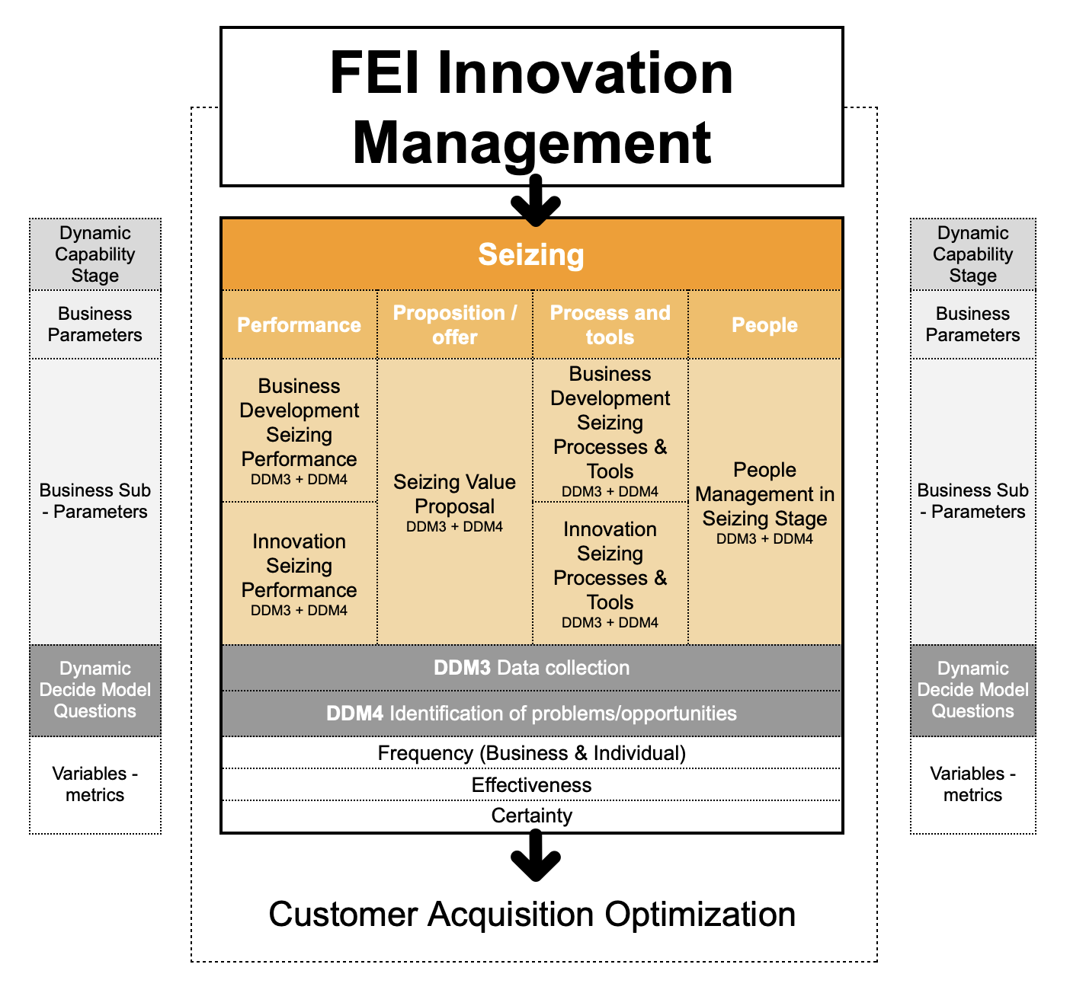

Building upon the groundwork established in the Sensing stage, the Seizing phase represents a pivotal shift, moving organisations from merely identifying opportunities to actively validating and refining these possibilities. This stage is crucial not for fully developing value propositions—that is the focus of the Transformation stage—but for systematically gathering, analysing, and interpreting data that substantiates and delineates specific opportunities. By doing so, organisations establish a strong, evidence-backed foundation for future development.

In today’s fast-paced environment, where rapid shifts and intense competition define the business landscape, the Seizing stage enables organisations to transform insights into structured, well-defined opportunities. Rather than simply choosing a course of action, this phase is characterised by strategic decision-making aimed at validating and prioritising opportunities with the highest potential, thus setting the groundwork for sustainable competitive advantage in the long term.

Our exploration of the Seizing stage within the 4P innovation model framework—Performance, Proposition, Process & Tools, and People—delves into how each dimension enables organisations to navigate this stage effectively.

At the core of Seizing lies the concept of dynamic capabilities, as articulated by David Teece. In this framework, Seizing represents an organisation’s capacity to systematically assess, validate, and select opportunities that have emerged from the Sensing stage, with a particular emphasis on understanding their feasibility and alignment with broader strategic goals. By establishing clear parameters around these opportunities, organisations are better positioned to commit resources and develop comprehensive strategies in the forthcoming Transformation stage.

In the Seizing stage, each of the 4P parameters plays a critical role:

**Performance** in Seizing centres on data collection and analysis to support business development and innovation. This involves measuring potential revenue growth, market share expansion, and returns on investment associated with each identified opportunity. Instead of developing new products or services, the focus remains on validating which ideas possess the most viable business case, allowing organisations to allocate resources strategically.

Under **Proposition**, the Seizing stage shifts the emphasis to defining specific customer needs and preferences that underpin an opportunity. Organisations leverage customer insights to craft a clear and compelling value proposition, refining their understanding of unique selling points and differentiators. This process ensures that opportunities are substantiated with evidence, preparing the groundwork for the value proposition development that will occur in Transformation.

In **Process & Tools**, organisations utilise data-gathering mechanisms and analytical tools to validate potential opportunities and ensure they are aligned with strategic objectives. These tools may include market research platforms, CRM systems, and digital analytics to assess market demand and competitive positioning. Rather than implementing solutions, the focus in Seizing is on optimising data collection and workflow efficiency to ensure that the insights gathered are actionable and relevant.

The role of **People** in Seizing is to cultivate a data-driven culture that values evidence-based decision-making. Managers and teams engage in collaborative assessment of opportunities, focusing on shared insights to validate which options are most feasible. Leadership in this stage involves guiding teams through a rigorous, structured approach to opportunity analysis, ensuring alignment with organisational objectives and strategic clarity.

By breaking down the Seizing stage into specific sub-parameters, we gain deeper insight into how organisations operate in this critical phase:

* **Business Development Performance**: During Seizing, organisations focus on gathering data to substantiate business development opportunities. This includes assessing customer dynamics, geographic expansion potential, and revenue trajectories, enabling a refined approach to market positioning. Objectives in this phase are centred around validating market fit and establishing performance metrics that guide resource allocation.
* **Innovation Performance**: The emphasis here is on validating the potential of new innovations before committing to full development. Organisations assess factors such as market acceptance and potential for R&D investment, examining how well an innovation aligns with industry benchmarks. Intellectual property considerations and potential cost efficiencies are reviewed to identify viable innovation paths that can be pursued further in Transformation.
* **Value Proposition**: Seizing involves articulating a preliminary value proposition grounded in verified customer insights. This includes validating customer pain points, preferences, and unique differentiators. The goal is to ensure that the opportunity aligns with real market needs, creating a solid foundation for the full development of the value proposition in the Transformation stage.
* **Process Improvements**: In Seizing, organisations refine processes and implement tools that enhance data accuracy and workflow efficiency. Instead of executing changes, they focus on optimising the mechanisms through which opportunities are evaluated, setting up robust systems for ongoing data collection and analysis.
* **Management Practices**: Organisations strengthen performance management to ensure that data collection and opportunity validation are systematic and rigorous. Leaders set specific objectives, provide constructive feedback, and encourage a culture of continuous improvement, equipping teams with the clarity needed to focus on high-impact opportunities.

Central to our analysis of Seizing are the **Dynamic Decide Model Questions** (DDM3 and DDM4):

* **Data Collection (DDM3)**: This evaluates the organisation’s ability to gather data that supports validation and refinement of business development, innovation, and value proposition opportunities. By systematically collecting and analysing data, organisations can establish clear parameters around each opportunity, assessing its potential through quantifiable evidence.
* **Identification of Problems/Opportunities (DDM4)**: Here, organisations focus on discerning specific solutions or reconfigurations within the identified opportunities. This step involves recognising which opportunities are most promising and feasible, as well as pinpointing any associated challenges that need to be addressed.

In understanding the Seizing stage, we also consider the variables of **Frequency, Effectiveness, and Certainty (FEC)**:

* **Frequency** measures how regularly organisations engage in data collection and opportunity assessment. Frequent, consistent engagement in these activities indicates a proactive approach to refining and validating potential strategies.
* **Effectiveness** evaluates how successful these activities are in producing actionable insights. High effectiveness suggests that the organisation not only gathers relevant data but also interprets it effectively to validate viable opportunities.
* **Certainty** captures the level of confidence teams have when assessing opportunities. While certainty can drive decisive action, it must be balanced with a readiness to adapt based on new data or insights.

This approach to Seizing sets a firm foundation for the Transformation stage, where value propositions will be fully developed and implemented. By meticulously validating opportunities and establishing clear priorities, organisations in Seizing ensure they are positioned to make impactful investments and pursue strategies with a high likelihood of success.

## 8 B Seizing / P1.1 Performance + Business Development / DM3 - DM4

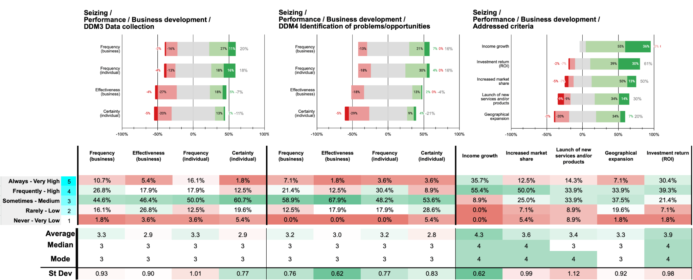

For DDM3, 37.5% of participants indicate that their organisations *always* or *frequently* collect data or evidence to support business development improvements for customer acquisition (10.7% *always*, 26.8% *frequently*). Individual participation is similar, with 34% *always* or *frequently* involved in these activities (16.1% *always*, 17.9% *frequently*). However, only 23.3% rate their organisations' effectiveness in data collection as *high* or *very high* (5.4% *very high*, 17.9% *high*), and a mere 14.3% experience a *high* or *very high* level of certainty in their roles (1.8% *very high*, 12.5% *high*). The majority of responses fall into the *sometimes* category, with 44.6% for organisational frequency and 50.0% for individual participation, suggesting moderate engagement in data collection activities but with room for improvement in effectiveness and confidence.

Regarding DDM4, which involves identifying potential solutions or reconfigurations in business development to capitalise on customer acquisition opportunities, organisational engagement is somewhat higher. A combined 66% of participants report that their organisations *always* or *frequently* engage in this activity (7.1% *always*, 58.9% *sometimes*). Individual participation mirrors this pattern, with 52% indicating they *always* or *frequently* participate (3.6% *always*, 48.2% *sometimes*). Perceived organisational effectiveness remains modest, with only 14.3% rating it as *high* or *very high*(1.8% *very high*, 12.5% *high*), and individual certainty is low, with just 12.5% experiencing a *high* or *very high* level of certainty (3.6% *very high*, 8.9% *high*). The prevalence of *sometimes* responses suggests that while organisations are engaging in identifying solutions, these efforts may lack consistency or depth.

When examining the addressed criteria during the identification of potential solutions, the data indicates that income growth is the most prioritised factor. A significant 91.1% of participants report that their organisations *always* or *frequently* address income growth (35.7% *always*, 55.4% *frequently*). Investment return (ROI) is also highly prioritised, with 69.7% addressing it *always* or *frequently* (30.4% *always*, 39.3% *frequently*). In contrast, criteria such as increased market share and launch of new services and/or products receive less emphasis, with 62.5% and 48.2% respectively indicating *always* or *frequently*. Geographical expansion is the least prioritised, with only 41% addressing it *always* or *frequently*.

These findings suggest that organisations are primarily focused on immediate financial performance metrics during the seizing stage, prioritising income growth and ROI over market expansion and innovation. The lower emphasis on launching new products or services and on geographical expansion may indicate a conservative strategic approach, concentrating on optimising existing offerings and markets rather than pursuing new opportunities.

**Main findings / insights:**

1. **Moderate Engagement in Data Collection**: A combined 37.5% of organisations always or frequently collect data to support business development improvements for customer acquisition, while individual involvement stands at 34%, indicating moderate but inconsistent engagement in data-gathering activities.
2. **Low Effectiveness and Certainty in Solution Identification**: Despite 66% organisational engagement in identifying business solutions, only 14.3% rate effectiveness as high, and individual certainty remains low at 12.5%, highlighting a gap in perceived success and confidence within solution-oriented efforts.
3. **Focus on Immediate Financial Outcomes Over Expansion**: Income growth and ROI are prioritised by 91.1% and 69.7% of organisations, respectively, while criteria like market share expansion (62.5%) and new product launches (48.2%) are less emphasised, indicating a focus on financial returns rather than market growth or innovation.

## 9 B Seizing / P1.2 Performance + Innovation / DM3 - DM4

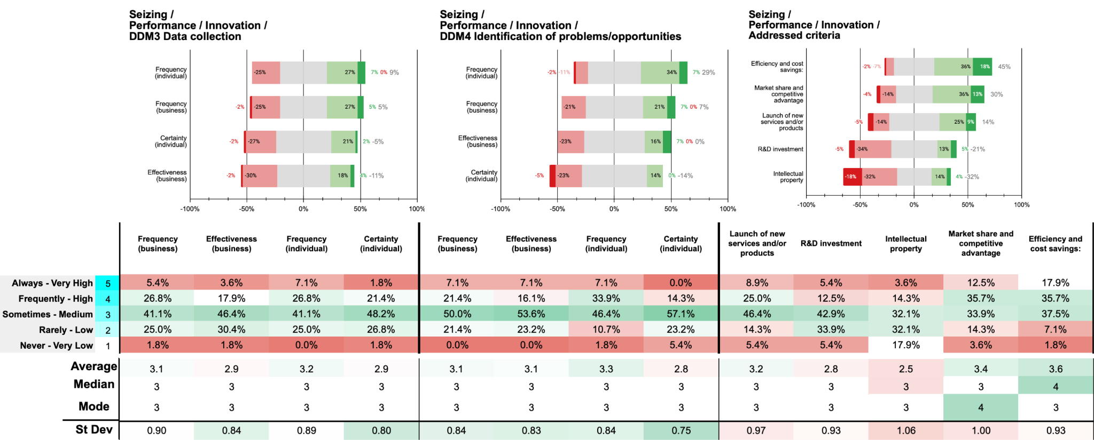

For DDM3, only 32.2% of participants indicate that their organisations *always* or *frequently* collect data or evidence to support innovation improvements for customer acquisition (5.4% *always*, 26.8% *frequently*). Individual participation mirrors this, with 33.9% *always* or *frequently* involved (7.1% *always*, 26.8% *frequently*). However, perceived organisational effectiveness is modest, with just 21.5% rating it as *high* or *very high* (3.6% *very high*, 17.9% *high*), and individual certainty is low, with only 23.2% experiencing a *high* or *very high* level of certainty (1.8% *very high*, 21.4% *high*). This suggests moderate engagement in data collection for innovation but highlights a need for improving effectiveness and boosting individual confidence.

Regarding DDM4, organisational engagement slightly improves, with 28.5% reporting that their organisations *always* or *frequently* identify potential innovation solutions to capitalise on customer acquisition opportunities (7.1% *always*, 21.4% *frequently*). Individual participation is higher, with 41.0% *always* or *frequently* involved (7.1% *always*, 33.9% *frequently*). Nonetheless, organisational effectiveness remains low, with only 23.2% rating it as *high* or *very high* (7.1% *very high*, 16.1% *high*), and individual certainty is modest, with 14.3% experiencing a *high* or *very high* level of certainty (0.0% *very high*, 14.3% *high*). This indicates that while individuals are more engaged in identifying innovation solutions, there is a lack of confidence and perceived effectiveness in these efforts.

When examining the addressed criteria during the identification of potential innovation solutions, Efficiency and Cost Savings emerges as the most prioritised factor, with 53.6% indicating their organisations *always* or *frequently* address it (17.9% *always*, 35.7% *frequently*). Market Share and Competitive Advantage follows, with 48.2% addressing it *always*or *frequently* (12.5% *always*, 35.7% *frequently*). In contrast, R&D Investment and Intellectual Property receive less emphasis, each with only 17.9% indicating these are *always* or *frequently* addressed. Launch of New Services and/or Products is considered by 33.9% (8.9% *always*, 25.0% *frequently*).

These findings suggest that during the seizing stage, organisations tend to focus on operational efficiencies and maintaining competitive positions rather than investing in long-term innovation drivers such as R&D and intellectual property. The limited engagement and low perceived effectiveness and certainty in data collection and solution identification for innovation highlight areas for improvement. Enhancing support for innovation activities, increasing investment in R&D, and fostering greater individual confidence could strengthen dynamic capabilities, enabling organisations to better capitalise on customer acquisition opportunities through innovative solutions.

**Main findings / insights:**

1. **Low Engagement in Innovation Data Collection**: Only 32.2% of organisations consistently gather data to support innovation improvements for customer acquisition, with individual participation at a similar 33.9%, indicating limited commitment to data-driven innovation efforts.
2. **Limited Effectiveness and Confidence in Innovation Solutions**: While 28.5% of organisations are engaged in identifying innovation solutions for customer acquisition, only 23.2% perceive these efforts as highly effective, and individual certainty remains modest at 14.3%, suggesting challenges in confidence and perceived impact.
3. **Focus on Efficiency Over Long-Term Innovation Investments**: Efficiency and cost savings are prioritised by 53.6% of organisations, while R&D and intellectual property are deprioritised, with only 17.9% indicating frequent focus. This conservative approach may hinder long-term competitive innovation.

## 10 B Seizing / P2.1 Offer + Value proposal / DM3 - DM4

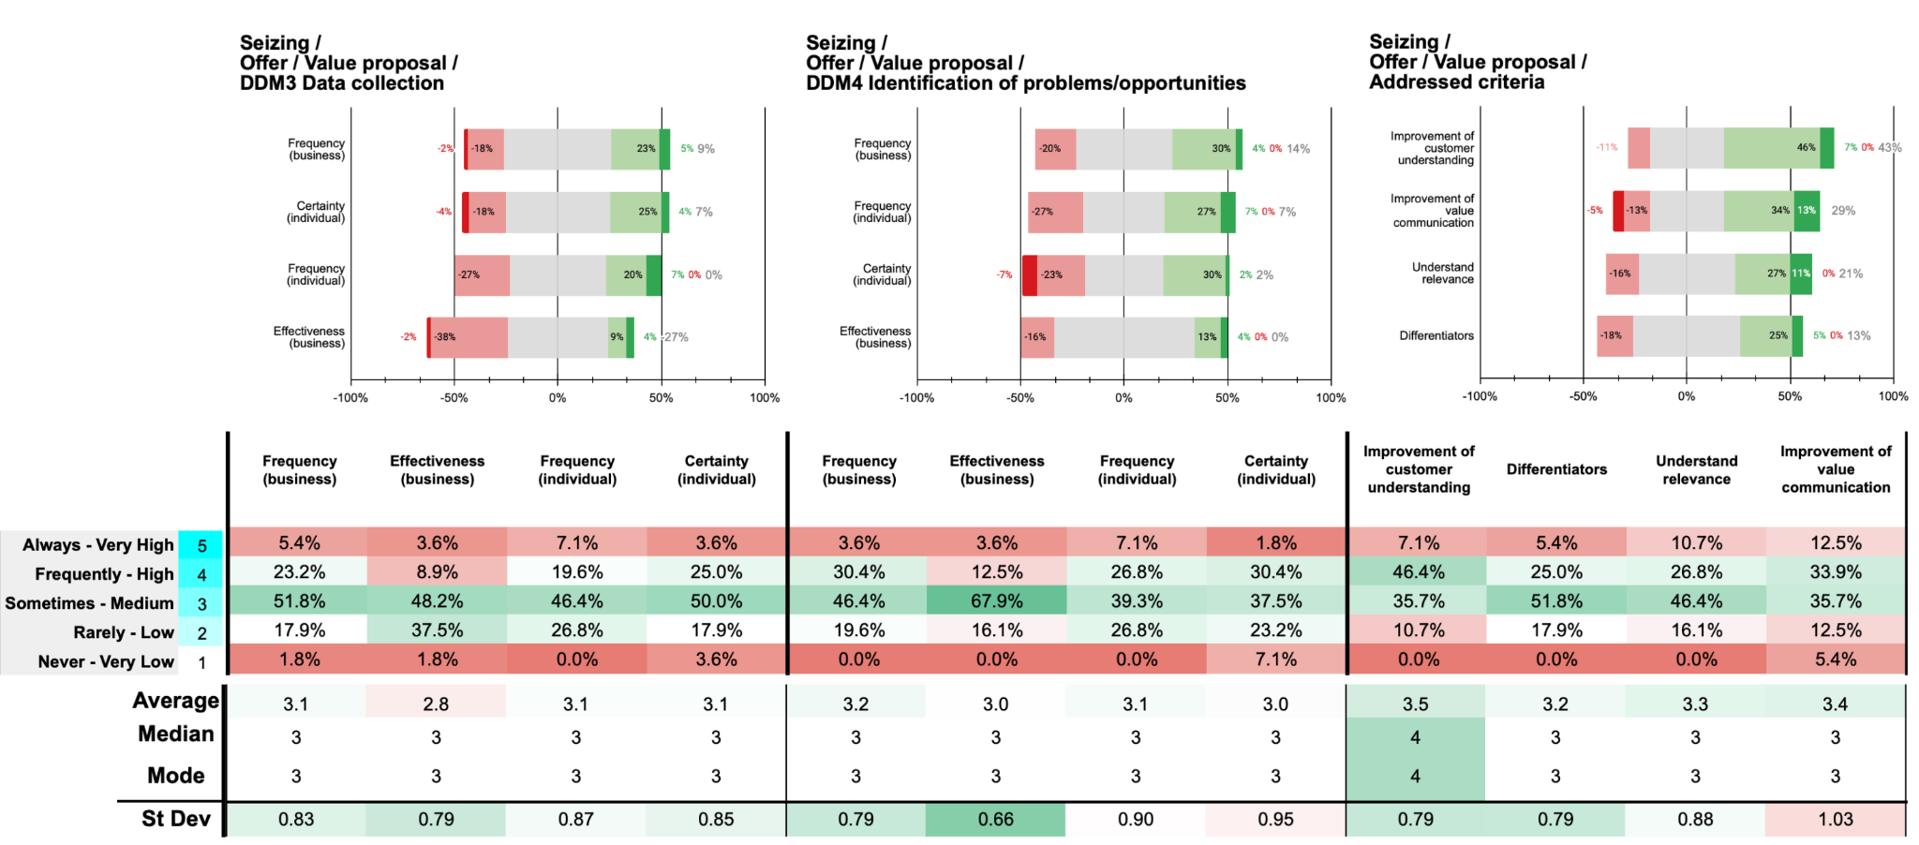

Organisational engagement in collecting data to support improvements in value propositions for customer acquisition is moderate. Only 28.6% of participants report their organisations *always* or *frequently* engage in this activity, with individual participation similar at 26.7%. Perceived organisational effectiveness is low at 12.5%, while individual certainty is slightly higher at 28.6%. These figures suggest that data collection efforts are not fully optimised within organisations.

Engagement increases when identifying potential solutions or reconfigurations of the value proposition, with 50% of participants indicating their organisations *always* or *frequently* undertake this activity. Individual participation stands at 33.9%, but perceived organisational effectiveness remains modest at 16.1%. Individual certainty decreases to 32.2%, indicating that despite increased organisational focus, employees may not feel fully confident in these processes.

The most prioritised criteria during the seizing stage are the enhancement of customer understanding and the improvement of value communication, addressed always or frequently by 53.5% and 46.4% of organisations, respectively. In contrast, differentiators are prioritised by only 30.4% of organisations, while understanding the relevance of market trends and industry challenges is addressed by 37.5%. This disparity suggests that organisations place significant emphasis on comprehending and effectively communicating value to customers, which are critical for customer acquisition and retention. However, the lower prioritisation of differentiators and market relevance indicates potential gaps in strategic positioning and adaptability.

Overall, organisations exhibit moderate data collection efforts and prioritise customer understanding and value communication for acquisition. However, the insufficient focus on differentiators and market trends, combined with low perceived effectiveness and individual confidence, underscores the need for more robust data strategies and strategic alignment to enhance competitive positioning and acquisition outcomes.

**Main findings / insights:**

1. **Moderate Engagement in Data Collection for Value Propositions**: Only 28.6% of organisations actively collect data to refine value propositions for customer acquisition, with a low perceived effectiveness (12.5%), indicating underutilised data practices in strategic value proposition improvements.
2. **Emphasis on Solution Identification with Low Confidence**: While 50% of organisations engage in identifying potential solutions to enhance value propositions, individual certainty is only at 32.2%, reflecting limited confidence in the process despite increased focus on solution development.
3. **Prioritisation of Customer Understanding Over Differentiation**: Organisations focus on enhancing customer understanding (53.5%) and value communication (46.4%) but place less emphasis on differentiators (30.4%) and market trends (37.5%), potentially impacting strategic positioning and adaptability.

## 11 B Seizing / P3.1 Process + Business Development / DM3 - DM4

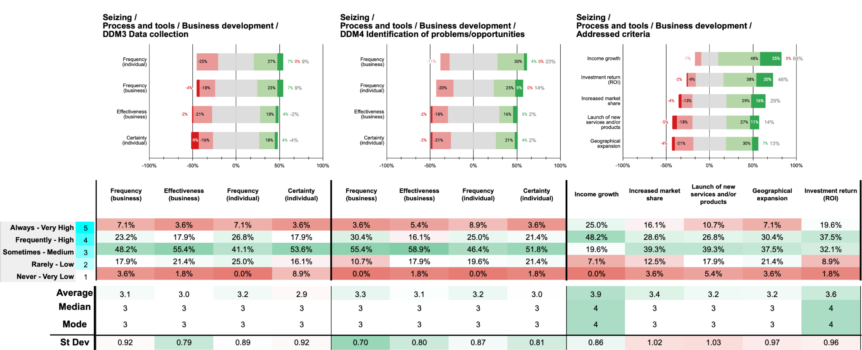

Organisational engagement in collecting data to support improvements in business development processes aimed at customer acquisition is moderate. Only 30.3% of participants report that their organisations *always* or *frequently* engage in this activity (7.1% *always*, 23.2% *frequently*). Individual participation is slightly higher at 33.9%. Perceived organisational effectiveness is low, with 21.5% rating it as *high* or *very high*, and individual certainty is modest at 21.5%. These figures suggest that data collection efforts are not fully optimised within organisations.

Engagement increases when identifying potential solutions or reconfigurations of business development processes, with 34.0% indicating their organisations *always* or *frequently* undertake this activity (3.6% *always*, 30.4% *frequently*). Individual participation is similar at 33.9%. Perceived organisational effectiveness remains modest at 21.5%, and individual certainty is 25.0%. Despite increased organisational focus, effectiveness and confidence levels remain moderate.

The most prioritised criterion is Income Growth, with 73.2% of participants indicating their organisations *always* or *frequently* address it (25.0% *always*, 48.2% *frequently*). Investment Return (ROI) follows at 57.1% (19.6% *always*, 37.5% *frequently*). Increased Market Share and Launch of New Services and/or Products are less emphasised, at 44.7% and 37.5% respectively. Geographical Expansion is the least prioritised, addressed *always* or *frequently* by only 37.5% of organisations.

During the seizing stage, organisations demonstrate moderate engagement in collecting data and identifying solutions for business development processes aimed at customer acquisition. However, low perceived effectiveness and individual certainty suggest room for improvement. The strong emphasis on income growth and ROI indicates a focus on immediate financial outcomes over innovation or market expansion.

**Main findings / insights:**

1. **Moderate Data Collection with Limited Effectiveness**: Only 30.3% of organisations consistently collect data for business development improvements, with low perceived effectiveness (21.5%), indicating room to optimise data-driven practices.
2. **Increased Engagement in Solution Identification but Modest Confidence**: Organisations show higher engagement (34.0%) in identifying solutions for business development, yet effectiveness and certainty remain moderate, with individual confidence at only 25.0%.
3. **Priority on Immediate Financial Metrics**: Income growth (73.2%) and ROI (57.1%) are prioritised over market expansion and innovation, suggesting a focus on short-term financial outcomes rather than strategic growth.

## 12 B Seizing / P3.2 Process + Innovation / DM3 - DM4

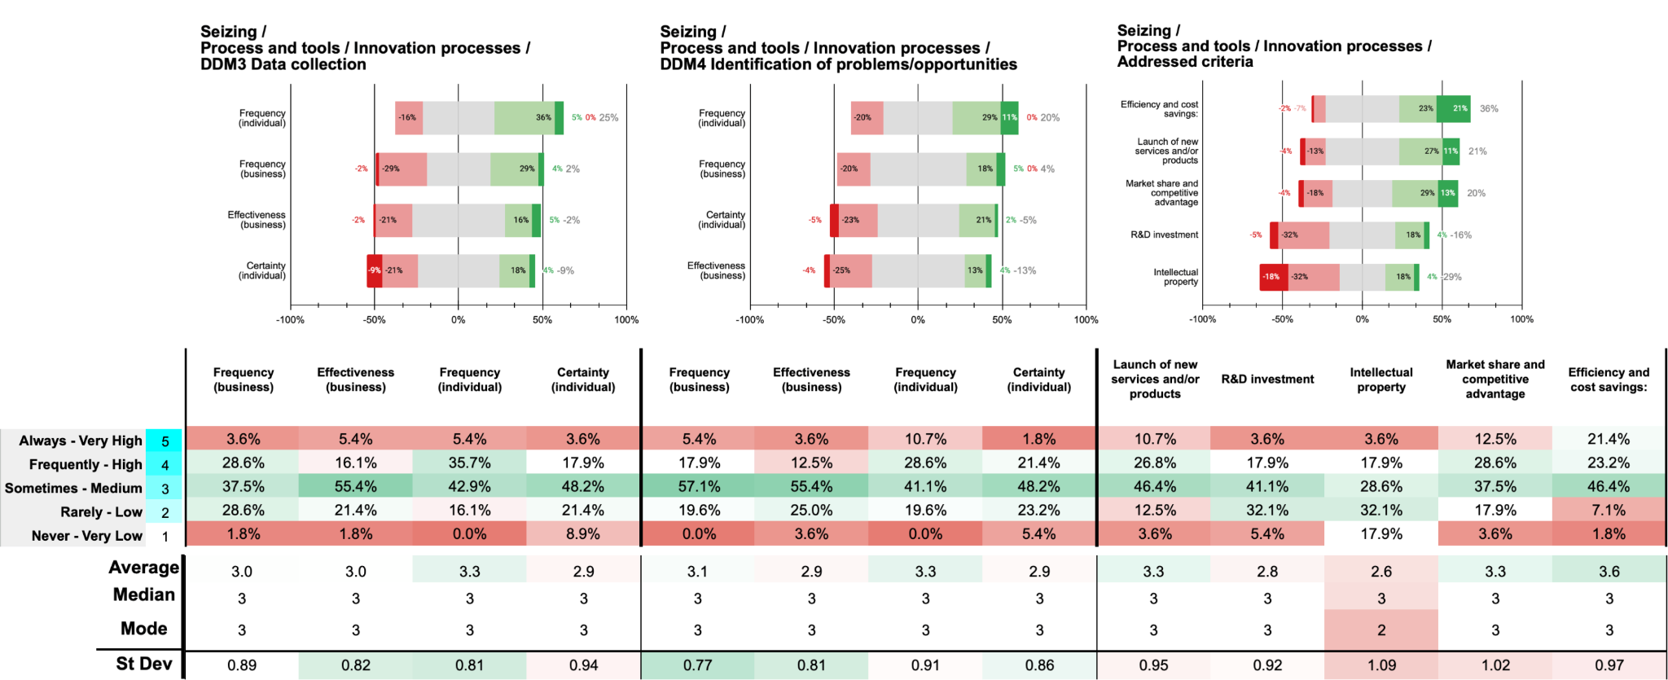

Organisational engagement in collecting data to support improvements in innovation processes benefiting customer acquisition is moderate. Only 32.2% of participants report their organisations *always* or *frequently* engage in this activity (3.6% *always*, 28.6% *frequently*). Individual participation is slightly higher at 41.1%, yet perceived organisational effectiveness is low, with just 21.5% rating it as *high* or *very high*. Individual certainty mirrors this, with 21.5% experiencing a *high* or *very high* level of confidence. These figures suggest that while data collection occurs, it may not be systematic or prioritised within organisations.

Engagement in identifying potential solutions or reconfigurations of innovation processes remains moderate, with 23.3% indicating their organisations *always* or *frequently* undertake this activity (5.4% *always*, 17.9% *frequently*). Individual participation is higher at 39.3%, but perceived organisational effectiveness is low at 16.1%. Individual certainty is modest at 23.2%, indicating that despite individual efforts, there may be a lack of organisational support or clear processes for identifying innovation solutions.

The most prioritised criterion is Efficiency and Cost Savings, with 44.6% of organisations *always* or *frequently* focusing on it (21.4% *always*, 23.2% *frequently*). Market Share and Competitive Advantage follows, emphasised by 41.1%. In contrast, Launch of New Services and/or Products is addressed by 37.5%, while R&D Investment and Intellectual Property are less prioritised, each with only 21.5% indicating these are *always* or *frequently* addressed. This pattern suggests a focus on operational efficiencies over long-term innovation investments.

During the seizing stage, organisations demonstrate moderate engagement in data collection and identification of innovation process solutions aimed at customer acquisition. However, low perceived effectiveness and individual certainty highlight potential gaps in organisational support and resource allocation. The emphasis on efficiency and cost savings over innovation drivers such as R&D and intellectual property may limit long-term competitiveness.

**Main findings / insights:**

1. **Moderate Data Collection with Low Effectiveness**: Only 32.2% of organisations consistently collect data for innovation improvements, and perceived effectiveness remains low at 21.5%, suggesting a need to enhance systematic data practices.
2. **Limited Engagement in Identifying Innovation Solutions**: While 23.3% of organisations actively identify innovation solutions, perceived effectiveness is low (16.1%) and individual confidence is moderate (23.2%), indicating a lack of strong organisational support.
3. **Focus on Efficiency Over Innovation Investment**: Efficiency and cost savings (44.6%) are prioritised over R&D and intellectual property (21.5%), potentially limiting long-term innovation and competitiveness.

## 13 B Seizing / P3.3 Process + Tools / Use of tools

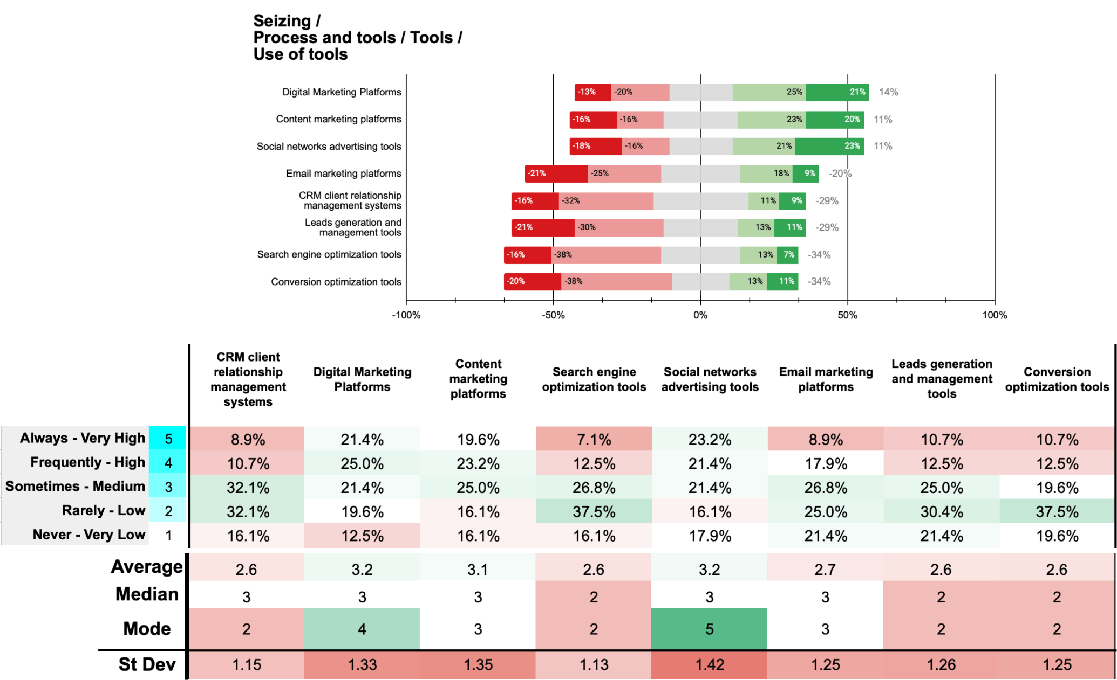

In the seizing stage of dynamic capabilities, organisations aim to capitalise on detected opportunities to maximise market acceptance and income. The utilisation of various marketing and customer engagement tools reflects this effort. The data indicates that Digital Marketing Platforms and Social Networks Advertising Tools are the most widely used, with 46.4% and 44.6% of participants respectively reporting *very high* or *high* levels of use. This suggests that organisations prioritise digital channels to reach and engage customers effectively.

Content Marketing Platforms also show substantial use, with 42.8% indicating *very high* or *high* utilisation. CRM Systems are moderately used, with only 19.6% reporting *very high* or *high* use, and a significant 32.1% indicating *medium* use. Search Engine Optimisation (SEO) Tools and Conversion Optimisation Tools have lower levels of high utilisation, with only 19.6% and 23.2% respectively reporting *very high* or *high* use, and higher percentages in the *low* or *very low* categories.

The data suggests that organisations focus more on tools that directly facilitate customer engagement and marketing efforts, such as digital marketing platforms and social media advertising. Tools that enhance customer relationship management and website performance, like CRM systems and conversion optimisation tools, are less prioritised. This may indicate a strategic emphasis on customer acquisition over retention and conversion optimisation during the seizing stage.

**Main findings / insights:**

1. **High Emphasis on Digital Marketing and Social Media**: Digital Marketing Platforms (46.4%) and Social Networks Advertising Tools (44.6%) show the highest levels of use, highlighting organisations' focus on digital channels for customer engagement during the seizing stage.
2. **Moderate Use of Content Marketing and CRM Systems**: Content Marketing Platforms are widely used (42.8%), while CRM Systems have moderate usage (19.6% high or very high), with a notable portion reporting medium utilisation, suggesting CRM is secondary to customer acquisition tools.
3. **Low Priority for Conversion and SEO Tools**: Tools for Search Engine Optimisation and Conversion Optimisation have limited high usage (19.6% and 23.2%, respectively), indicating a strategic focus on acquisition over retention and conversion, potentially impacting long-term customer relationships.

## 14 B Seizing / P4.1 People + Management / DM3 - DM4

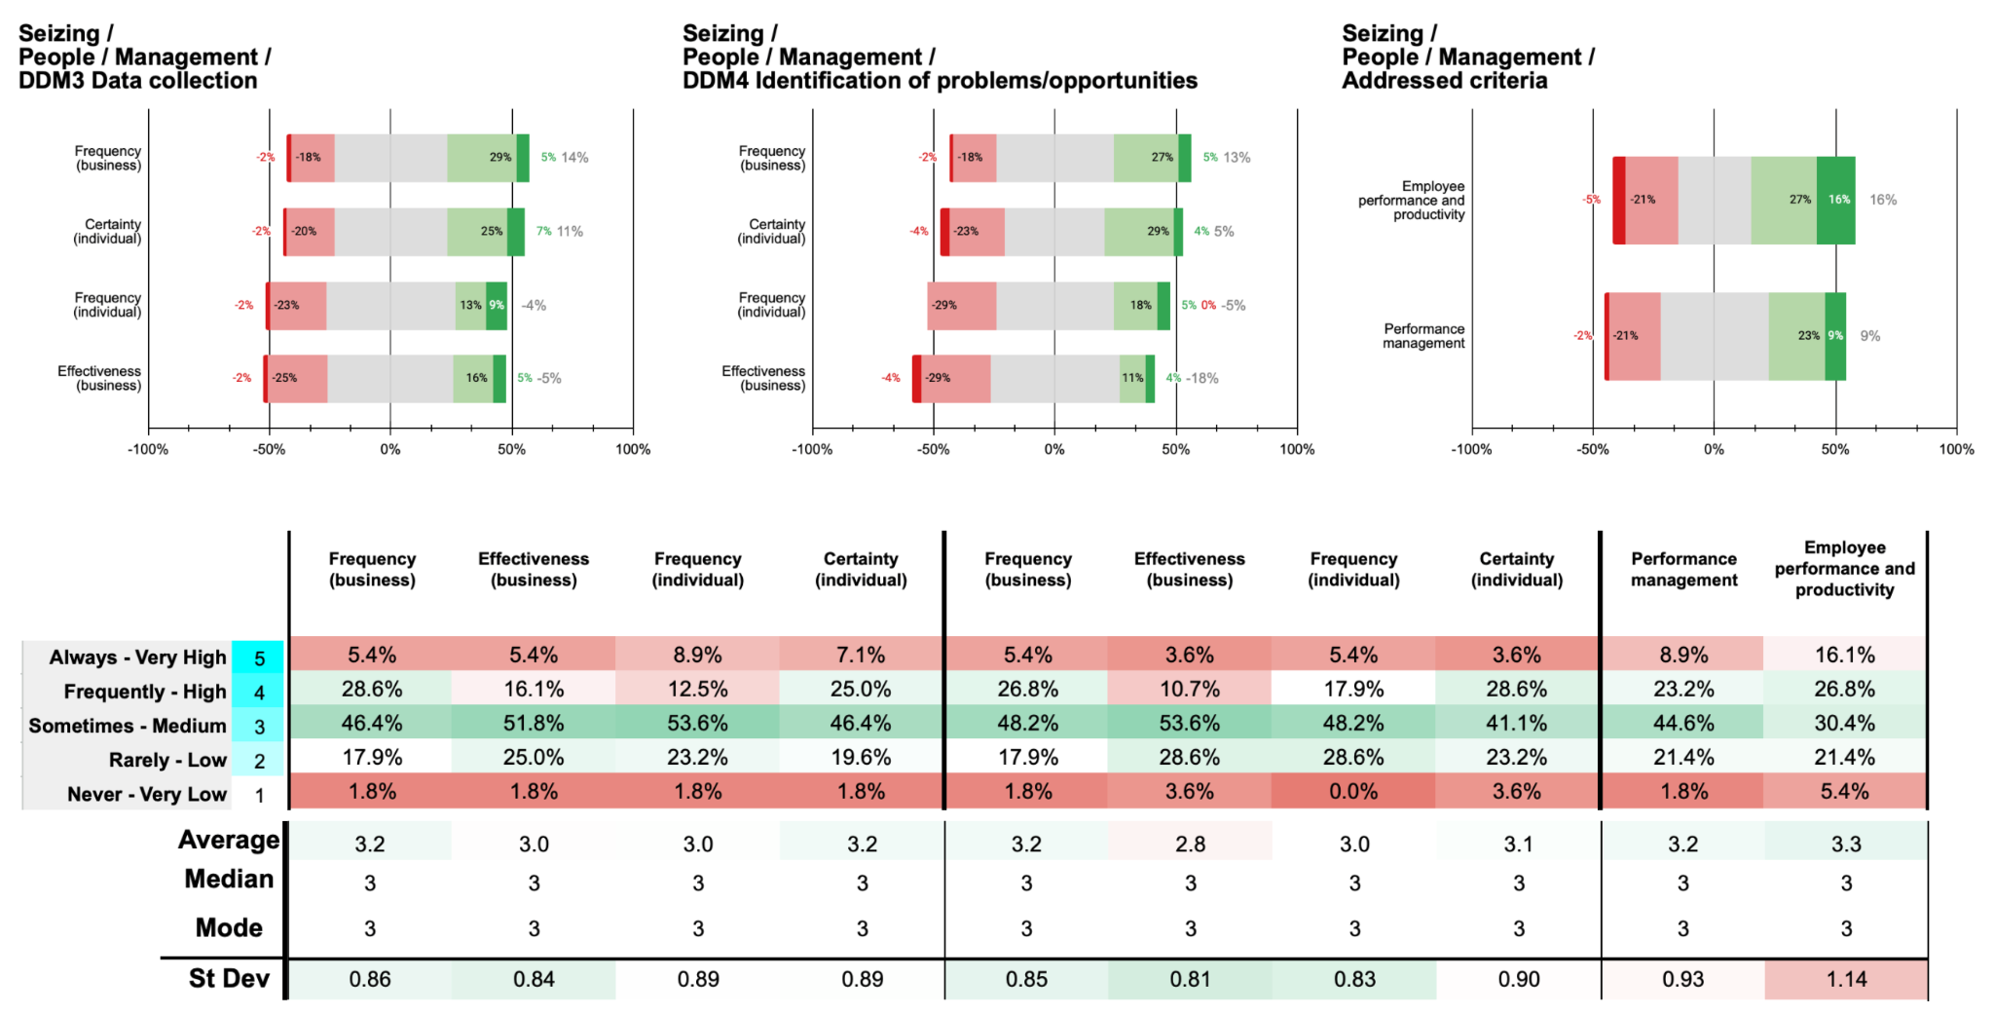

Organisational engagement in collecting data to support management improvements for customer acquisition is moderate. Only 34% of participants report that their organisations *always* or *frequently* engage in this activity (5.4% *always*, 28.6% *frequently*). Individual participation is lower at 21.4% (*always* 8.9%, *frequently* 12.5%). Perceived organisational effectiveness is low, with 21.5% rating it as *high* or *very high*, and individual certainty is modest at 32.1%. These figures suggest that data collection efforts for management improvements are not a primary focus within organisations.

Engagement increases when identifying potential management solutions or reconfigurations to boost customer acquisition, with 32.2% indicating their organisations *always* or *frequently* undertake this activity (5.4% *always*, 26.8% *frequently*). Individual participation is slightly higher at 23.3% (*always* 5.4%, *frequently* 17.9%). Perceived organisational effectiveness remains low at 14.3%, and individual certainty is modest at 32.2%. This indicates room for improvement in both organisational practices and individual confidence.

The most prioritised criterion is Employee Performance and Productivity, with 42.9% of organisations *always* or *frequently* addressing it (16.1% *always*, 26.8% *frequently*). Performance Management is less emphasised, with 32.1% indicating *always* or *frequently* (8.9% *always*, 23.2% *frequently*). This suggests a focus on individual employee outputs rather than systemic performance management processes. During the seizing stage, organisations show moderate engagement in data collection and identification of management solutions aimed at customer acquisition. However, low perceived effectiveness and individual certainty highlight areas for improvement. The emphasis on employee performance over performance management indicates a potential gap in strategic management practices.

**Main findings / insights:**

1. **Moderate Organisational Engagement in Data Collection**: Only 34% of organisations frequently engage in data collection to support management improvements for customer acquisition, with even lower individual participation (21.4%), indicating data collection is not fully prioritised in management practices.
2. **Low Effectiveness and Modest Confidence in Management Solutions**: While 32.2% of organisations engage in identifying management solutions for customer acquisition, perceived effectiveness remains low (14.3%), and individual certainty is modest (32.2%), suggesting areas for improvement in organisational support and strategic management.
3. **Focus on Employee Productivity Over Systemic Management**: Employee performance and productivity are prioritised by 42.9% of organisations, compared to 32.1% for broader performance management, indicating a focus on individual outputs rather than structured management practices, potentially impacting strategic cohesion.

## Analysis of the Seizing Stage in Organisational Innovation



**Engagement in Data Collection and Solution Identification**

The dataset reveals a nuanced landscape of organisational engagement in the seizing stage. For instance, in the domain of business development (DDM3), only 37.5% of participants report that their organisations consistently engage in data collection to support business development improvements for customer acquisition. This figure marginally surpasses individual participation rates at 34%, yet both reflect moderate involvement. The perceived organisational effectiveness in data collection stands dismally low at 23.3%, accompanied by a scant 14.3% of individuals experiencing high or very high certainty in their roles. These statistics indicate a fundamental disconnect between organisational initiatives and their perceived success, suggesting potential inadequacies in data management processes or strategic alignment.

Conversely, in the identification of potential solutions or reconfigurations within business development (DDM4), organisational engagement appears more pronounced, with 66% of respondents indicating frequent or consistent involvement. Individual participation aligns closely at 52%. Despite this heightened engagement, the effectiveness and certainty ratings remain underwhelming, with only 14.3% and 12.5% respectively attesting to high or very high levels. This disparity underscores persistent challenges in the execution of strategic initiatives, possibly attributable to insufficient resource allocation, inadequate training, or suboptimal communication mechanisms.

**Performance and Innovation Prioritisation**

A salient observation within the seizing stage is the pronounced emphasis on immediate financial metrics over long-term innovation drivers. Specifically, income growth emerges as the predominant criterion, with an overwhelming 91.1% of participants affirming its consistent prioritisation. Investment Return on Investment (ROI) follows closely at 69.7%, underscoring a strategic focus on enhancing financial performance. In contrast, increased market share and the launch of new services or products are less emphatically prioritised at 62.5% and 48.2% respectively, while geographical expansion lags behind at 41%. This proclivity towards short-term financial gains may inadvertently constrain organisational agility and innovation capacity, potentially impeding long-term competitiveness and adaptability.

In the realm of innovation (DDM3 and DDM4), the data mirrors this trend. Only 32.2% of organisations frequently engage in data collection to support innovation improvements, with similar individual participation rates at 33.9%. The effectiveness of these efforts is modest, with a mere 21.5% of organisations rating it highly, and individual certainty remains modest at 23.2%. When identifying innovation solutions, 53.6% prioritise efficiency and cost savings, while only 17.9% focus on R&D investment and intellectual property. This inclination towards operational efficiencies over foundational innovation drivers suggests a strategic conservatism that may undermine the organisation's capacity for breakthrough innovations and long-term value creation.

**Value Proposition Development and Communication**

The development and refinement of value propositions are critical for customer acquisition and retention. However, the data indicates that organisational engagement in collecting data to enhance value propositions is limited, with only 28.6% consistently involved. Individual participation is similarly restrained at 26.7%, and the perceived effectiveness plummets to a mere 12.5%. Despite these low engagement and effectiveness rates, identifying solutions or reconfigurations of value propositions sees a more robust participation rate of 50%, although effectiveness and certainty remain modest at 16.1% and 32.2% respectively.

The prioritisation within value proposition development reveals a strategic focus on enhancing customer understanding and improving value communication, addressed by 53.5% and 46.4% of organisations respectively. Conversely, differentiators and market relevance receive less emphasis, at 30.4% and 37.5%. This imbalance suggests that while organisations recognise the importance of understanding and communicating value, they may underinvest in differentiating their offerings and adapting to evolving market trends, potentially diminishing their competitive edge.

**Process Improvement in Business Development and Innovation**

Process optimisation is essential for enhancing organisational efficiency and effectiveness. In business development processes (DDM3), only 30.3% of organisations consistently identify and define process improvements, with individual participation slightly higher at 33.9%. The perceived effectiveness remains low at 21.5%, and individual certainty is similarly modest. This indicates that while there is a degree of engagement, the impact of process improvements is limited, possibly due to fragmented implementation or inadequate support structures.

In innovation processes (DDM4), the pattern persists with 32.2% of organisations frequently identifying process improvements, and individual participation at 25.0%. The effectiveness and certainty ratings remain unimpressive at 21.5% and 25.0% respectively. The prioritisation criteria within process improvement reveal a continued focus on income growth (73.2%) and ROI (57.1%), with less attention to increased market share (44.7%) and the launch of new services or products (37.5%). This persistent focus on financial metrics over innovation-driven process enhancements underscores a strategic inertia that may stifle innovation and limit organisational adaptability.

**Utilisation of Tools During the Seizing Stage**

The strategic deployment of tools is instrumental in the seizing stage, facilitating market penetration and customer engagement. The data highlights a significant utilisation of digital marketing platforms (46.4%) and social networks advertising tools (44.6%), reflecting a robust emphasis on digital channels for customer acquisition. Content marketing platforms also demonstrate substantial usage at 42.8%. However, tools that enhance customer relationship management (CRM) and conversion optimisation exhibit lower adoption rates, at 19.6% and 23.2% respectively. This disparity suggests that organisations prioritise acquisition-focused tools over those that foster customer retention and operational optimisation, potentially undermining long-term customer loyalty and process efficiency.

The limited adoption of CRM systems and conversion optimisation tools may stem from resource constraints, perceived complexity, or a lack of technical expertise. This underutilisation could impede the organisation’s ability to effectively manage customer relationships and maximise conversion rates, thereby limiting the overall efficacy of seizing strategies.

**Management Practices and Employee Confidence**

Effective management practices are paramount for the successful implementation of seizing strategies. The data reveals that organisational engagement in collecting data to support management improvements is moderate, with only 34% of organisations consistently involved. Individual participation is notably lower at 21.4%, and perceived organisational effectiveness is marginal at 21.5%. Individual certainty is somewhat higher at 32.1%, yet still indicative of moderate confidence levels.

When it comes to identifying management solutions or reconfigurations to boost customer acquisition, 32.2% of organisations report consistent engagement, with individual participation at 23.3%. The perceived effectiveness plummets further to 14.3%, while individual certainty remains modest at 32.2%. These figures suggest that management practices may lack strategic alignment, robust implementation frameworks, or sufficient resource allocation to effectively support seizing activities.

The prioritisation within management practices indicates a focus on employee performance and productivity (42.9%) over performance management systems (32.1%). This emphasis on individual outputs rather than systemic performance management may reflect a fragmented approach to managing performance, potentially limiting the organisation’s ability to cohesively drive strategic objectives and innovation initiatives.

**Conclusion**

The analysis of the seizing stage elucidates a landscape where organisations exhibit moderate engagement in strategic activities aimed at capitalising on identified opportunities. However, this engagement is consistently undermined by low perceived effectiveness and individual certainty, suggesting systemic deficiencies in execution, communication, and resource allocation. The pronounced focus on immediate financial metrics, such as income growth and ROI, over long-term innovation drivers, poses significant constraints on organisational adaptability and sustained competitiveness.

Furthermore, the underutilisation of advanced analytical and CRM tools, coupled with a strategic emphasis on customer acquisition over retention and process optimisation, indicates potential areas for strategic realignment. The challenges in management practices, characterised by a focus on individual performance over systemic management processes, further compound the limitations in effectively leveraging seizing strategies.

# **C Transformation**

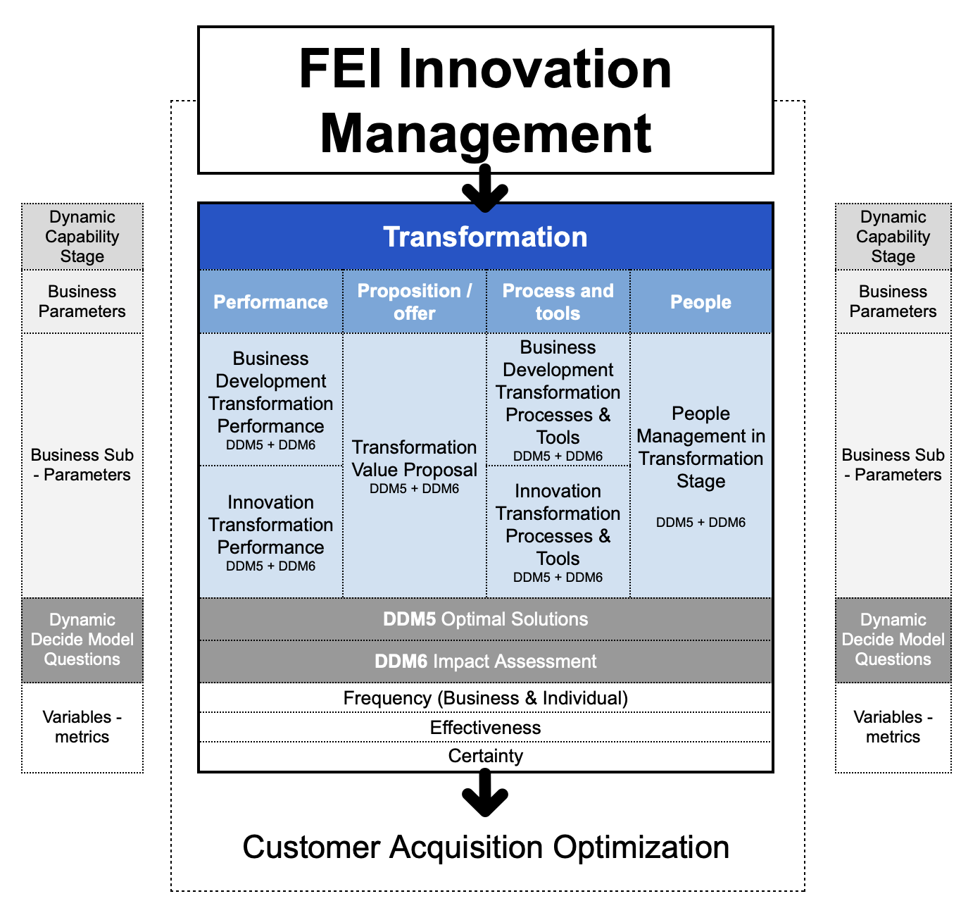

Following the Seizing stage, where organisations validate and prioritise opportunities, the Transformation stage represents the culmination of these efforts—where validated ideas evolve into tangible value propositions and measurable outcomes. This stage is centred on the systematic implementation of well-defined offerings, optimising processes, and assessing the impact of these transformations on organisational goals, particularly in terms of customer acquisition and retention.

In a constantly shifting marketplace, the Transformation stage is pivotal in ensuring that organisations adapt their offerings to meet dynamic customer needs, sustain competitive advantage, and drive meaningful growth. This stage involves deploying resources, refining innovations, and embedding value propositions into the organisational structure to ensure long-term impact. With the focus on generating optimal solutions, Transformation emphasises the execution of strategic plans and the realisation of value through measurable performance outcomes.

Our exploration of the Transformation stage delves into the interconnected dimensions of our 4P framework—Performance, Proposition, Process & Tools, and People—offering a comprehensive understanding of how organisations navigate this critical phase of actualising value.

**Dynamic Capabilities in Transformation**

At the core of the Transformation stage lies the principle of reconfiguring, as outlined by David Teece's dynamic capabilities framework. Transformation is understood as the capacity of organisations to reconfigure and realign resources, processes, and strategies to maximise the impact of their innovations and to adapt offerings effectively within the market. The focus here shifts from validation to the actualisation of value propositions through structured implementation and systematic impact assessment, captured in DDM5 (Optimal Solutions) and DDM6 (Impact Assessment) metrics.

**Performance** during the Transformation stage emphasises the impact of business development initiatives. Here, organisations assess how successfully their innovations translate into measurable outcomes, such as revenue growth, customer acquisition, and market share expansion. Rather than simply launching products or services, the focus in Transformation is on generating quantifiable business value and gauging the effectiveness of these initiatives in fostering customer engagement and sustaining growth.

Under **Proposition**, the emphasis is on translating validated ideas into fully realised offerings that resonate with customer needs. Organisations focus on crafting unique, competitive value propositions that align closely with market demands, ensuring differentiation and relevance. This stage involves finalising and optimising products or services to maximise customer impact and loyalty, leveraging insights gained during earlier stages to enhance the offering’s appeal.

**Process & Tools** during Transformation are geared towards optimising resource allocation and operational efficiency, integrating advanced tools to ensure that transformation processes are effective and aligned with strategic goals. This may include resource management platforms, financial forecasting tools, and project management systems to streamline implementation and maximise productivity. The objective is to create robust systems that support seamless execution, continuous monitoring, and adaptability to market changes.

The role of **People** in Transformation is crucial as the workforce executes strategies, engages in continuous learning, and aligns efforts with organisational goals. Leadership practices are refined to emphasise performance management, feedback loops, and team alignment with the company's mission. The focus in Transformation is on fostering a culture of accountability, adaptability, and sustained productivity, ensuring that teams are motivated and equipped to drive impactful results.

The Transformation stage can be further broken down into specific sub-parameters:

* **Business Development Transformation Performance**: This aspect evaluates the effectiveness of business development strategies in achieving customer acquisition, market share growth, and ROI. The emphasis is on measuring the impact of new offerings and initiatives, including product launches and geographic expansion, while ensuring alignment with financial objectives and market needs. Metrics are closely monitored to confirm that the transformation efforts translate into substantive organisational growth.
* **Innovation Transformation Performance**: Here, organisations assess the market acceptance and performance of innovations, measuring outcomes like R&D effectiveness, intellectual property acquisition, and efficiency gains. This evaluation includes tracking how well innovations meet market expectations and support competitive positioning. Investment in R&D and protection of intellectual assets are considered within the broader framework of impact assessment to ensure that innovations drive substantial, measurable results.
* **Transformation Value Proposition**: During Transformation, organisations concentrate on delivering a value proposition that fully addresses customer needs and differentiates the brand in the market. This involves refining the offering to enhance customer satisfaction and loyalty, ensuring relevance to evolving market conditions, and optimising communication strategies. The effectiveness of these offerings is measured through customer feedback, conversion rates, and repeat business, aiming to maximise the impact on customer acquisition and retention.
* **Business Development Transformation Processes & Tools**: This component focuses on the optimisation of business processes to support the seamless execution of strategies. By employing project management, financial forecasting, and resource allocation tools, organisations streamline workflows, reduce waste, and enhance operational efficiency. These processes are continuously refined to ensure that transformation initiatives are executed effectively and contribute to measurable growth.
* **People Management in Transformation Stage**: Effective transformation relies on a high-performance culture that prioritises continuous improvement and alignment with strategic goals. Performance management practices are intensified, integrating feedback, setting clear objectives, and fostering a collaborative culture. In this stage, employee development and resource alignment are critical to ensuring that the workforce is prepared to support transformational goals and deliver impactful results.

Central to the Transformation stage are the **Dynamic Decide Model Questions (DDM5 and DDM6)**, which focus on optimal solution generation and impact assessment:

* **Optimal Solutions (DDM5)**: This question addresses how effectively organisations develop solutions, reconfigurations, and action plans that realise value propositions and achieve measurable impact. Organisations assess the quality of solutions implemented to support customer acquisition and retention, measuring their alignment with organisational objectives and market expectations.
* **Impact Assessment (DDM6)**: This question evaluates how well organisations monitor and assess the performance of transformation initiatives. Through consistent impact assessment, organisations ensure that transformation efforts yield the intended benefits, adjusting strategies as needed based on performance data.

In examining the Transformation stage, we also consider the **Frequency, Effectiveness, and Certainty (FEC)** metrics:

* **Frequency** measures how often organisations and individuals engage in transformation activities, reflecting a commitment to sustained improvement and responsiveness to market dynamics.
* **Effectiveness** assesses the success rate of transformation efforts in achieving desired outcomes. High effectiveness indicates that the organisation’s strategies and processes are well-optimised, contributing to measurable growth and customer acquisition.
* **Certainty** captures the confidence levels of individuals and teams when implementing transformation initiatives. High certainty can enhance decision-making and execution speed, although flexibility and openness to feedback remain essential for continuous improvement.

The Transformation stage is more than mere implementation; it is the realisation of strategic intent and the execution of refined solutions to generate measurable impact. Organisations that excel in transformation are well-positioned to maintain a competitive edge, drive customer loyalty, and achieve long-term growth through adaptive and impactful innovation strategies.

## 15 C Transformation / P1.1 Performance + Business Development / DM5 - DM6

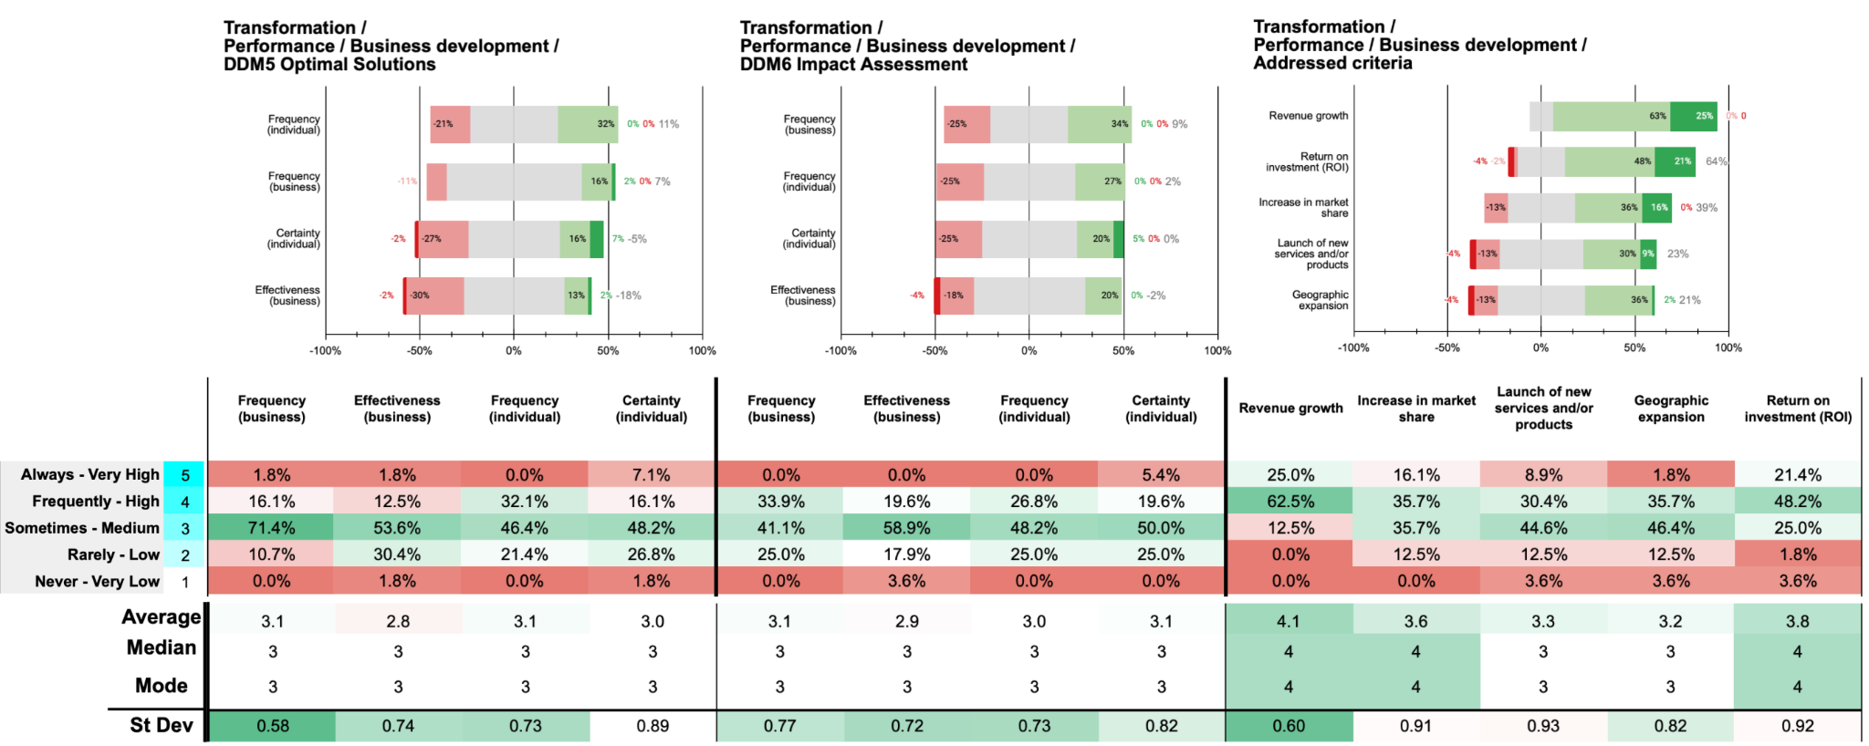

Organisational engagement in developing optimal business development solutions for customer acquisition is moderate, with only 17.9% of participants reporting their organisations *always* or *frequently* engage in this activity. Individual participation is slightly higher at 32.1%. Perceived organisational effectiveness is low, with just 14.3% rating it as *high* or *very high*. Individual certainty is modest at 23.2%. These figures suggest that developing optimal solutions is not a strong focus during the transformation stage.

Engagement increases in evaluating and monitoring business development performance, with 33.9% of participants indicating their organisations *frequently* engage in this activity. Individual participation is 26.8%. Perceived organisational effectiveness remains modest at 19.6%, and individual certainty is 25.0%. This indicates that while some evaluation occurs, these practices may not be sufficiently systematic within organisations.

The most prioritised criterion is Revenue Growth, with 87.5% of participants indicating their organisations *always* or *frequently* address it. Return on Investment (ROI) is also highly emphasised, addressed by 69.6% of organisations. Increase in Market Share is considered by 51.8%. In contrast, Launch of New Services and/or Products and Geographic Expansion are less prioritised, addressed by 39.3% and 37.5% respectively. This suggests a focus on immediate financial outcomes over innovation and expansion initiatives during the transformation stage.

During the transformation stage, organisations show moderate engagement in developing business development solutions and evaluating performance against customer acquisition objectives. Low perceived effectiveness and individual certainty highlight areas for improvement. The strong emphasis on revenue growth and ROI indicates a focus on short-term financial metrics, potentially at the expense of innovation and market expansion.

**Main findings / insights:**

1. **Low Engagement in Solution Development for Business Development**: Only 17.9% of organisations frequently develop optimal business development solutions for customer acquisition, with individual participation slightly higher at 32.1%. Organisational effectiveness is low (14.3%), and individual certainty is modest (23.2%).
2. **Moderate Engagement in Performance Evaluation**: Engagement increases to 33.9% for organisational participation in evaluating and monitoring business development performance, with 26.8% individual participation. However, effectiveness (19.6%) and certainty (25.0%) remain modest.
3. **Focus on Short-term Financial Metrics**: Revenue Growth is prioritised by 87.5% of organisations, followed by ROI (69.6%) and Market Share (51.8%). Launch of New Products (39.3%) and Geographic Expansion (37.5%) are less emphasised, indicating a focus on immediate financial outcomes over innovation and growth.

## 16 C Transformation / P1.2 Performance + Innovation / DM5 - DM6

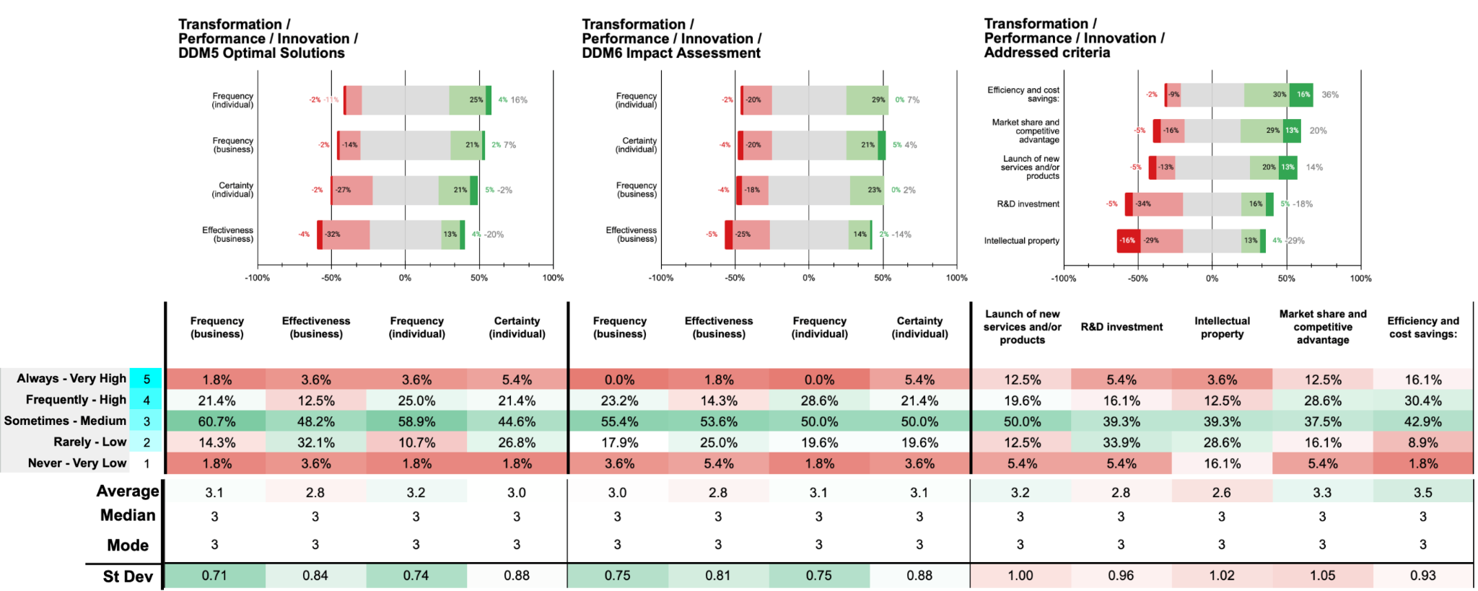

Organisational engagement in developing optimal innovation solutions and action plans for customer acquisition is moderate. Only 23.2% of participants report their organisations *always* or *frequently* engage in this activity (1.8% *always*, 21.4% *frequently*). Individual participation is slightly higher at 28.6%. Perceived organisational effectiveness is low, with 16.1% rating it as *high* or *very high*, and individual certainty is modest at 26.8%. These figures suggest that developing optimal innovation solutions is not strongly emphasised during the transformation stage.

Engagement in evaluating and monitoring innovation performance against customer acquisition objectives is slightly higher, with 23.2% indicating their organisations *always* or *frequently* engage in this activity (none *always*, 23.2% *frequently*). Individual participation is at 28.6%. Perceived organisational effectiveness remains low at 16.1%, and individual certainty is similar at 26.8%. This indicates that while some evaluation occurs, these practices may not be systematic or prioritised within organisations.

The most prioritised criterion is Efficiency and Cost Savings, with 46.5% of organisations *always* or *frequently* addressing it (16.1% *always*, 30.4% *frequently*). Market Share and Competitive Advantage is also emphasised by 41.1% (12.5% *always*, 28.6% *frequently*). In contrast, Launch of New Services and/or Products is addressed by 32.1%, R&D Investment by 21.5%, and Intellectual Property is least prioritised at 16.1%. This suggests a focus on operational efficiencies over innovation investments during the transformation stage. During the transformation stage, organisations show moderate engagement in developing optimal innovation solutions and evaluating performance, but low perceived effectiveness and individual certainty highlight areas for improvement. The emphasis on efficiency and cost savings over innovation drivers like R&D and intellectual property may limit long-term competitiveness.

**Main findings / insights:**

1. **Moderate Engagement in Innovation Solution Development**: Only 23.2% of organisations always or frequently engage in developing optimal innovation solutions for customer acquisition, with slightly higher individual participation at 28.6%. Organisational effectiveness is low (16.1%), and individual certainty is modest (26.8%).
2. **Limited Evaluation of Innovation Performance**: Engagement in evaluating innovation performance against customer acquisition objectives is also moderate, with 23.2% organisational participation and 28.6% individual participation. Effectiveness and certainty remain low, both at around 16.1% and 26.8% respectively.
3. **Focus on Efficiency and Competitive Advantage**: Efficiency and Cost Savings are prioritised by 46.5% of organisations, while Market Share and Competitive Advantage are addressed by 41.1%. In contrast, lower emphasis is placed on Launching New Products (32.1%), R&D Investment (21.5%), and Intellectual Property (16.1%), indicating a focus on short-term efficiencies over long-term innovation investments.

## 17 C Transformation / P2.1 Offer + Value proposal / DM5 - DM6

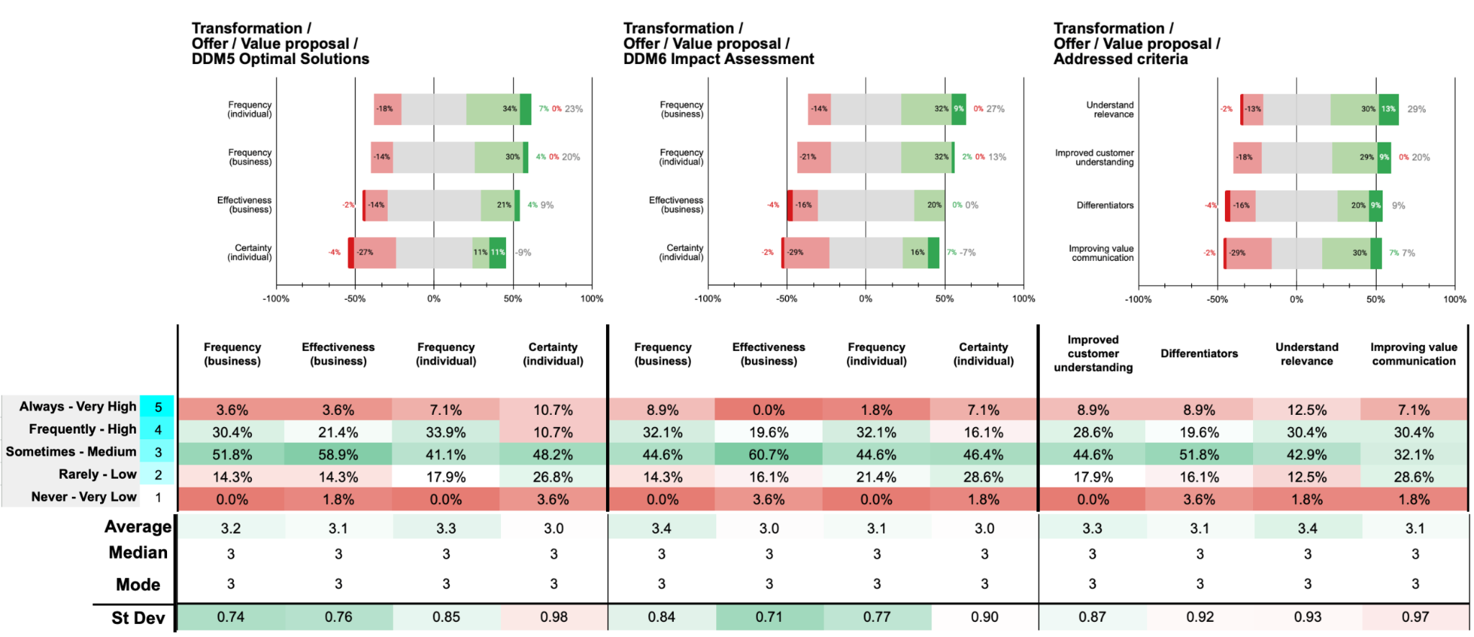

Organisational engagement in developing optimal value proposition solutions and action plans for customer acquisition during the transformation stage is moderate. Only 34% of participants report their organisations *always* or *frequently* engage in this activity (3.6% *always*, 30.4% *frequently*). Individual participation is slightly higher at 41% (7.1% *always*, 33.9% *frequently*). However, perceived organisational effectiveness is low, with only 25% rating it as *high* or *very high*(3.6% *very high*, 21.4% *high*). Individual certainty is modest at 21.4%, indicating that employees may not feel fully confident in developing these solutions.

Engagement in evaluating and monitoring the performance of value propositions aimed at customer acquisition is moderate. A combined 41% of participants indicate their organisations *always* or *frequently* undertake this activity (8.9% *always*, 32.1% *frequently*). Individual participation is similar at 33.9%. However, perceived organisational effectiveness remains low at 19.6%, and individual certainty is also modest at 23.2%. This suggests that while organisations are attempting to assess the impact of their value propositions, there is room for improvement in effectiveness and employee confidence.

The most prioritised criterion is Understanding Relevance (market trends and industry challenges), addressed frequently by 42.9% of participants. Improved Customer Understanding and Improving Value Communication are each addressed by 37.5% of organisations, whereas Differentiators is less emphasised at 28.5%. This indicates a moderate focus on aligning value propositions with market trends but less emphasis on differentiating offerings and enhancing communication.

During the transformation stage, organisations exhibit moderate engagement in developing and assessing value propositions for customer acquisition. However, low perceived effectiveness and individual certainty suggest these practices are not fully optimised. The emphasis on understanding market relevance shows awareness of external factors, but the lower prioritisation of differentiators and value communication may limit the effectiveness of value propositions.

**Main findings / insights:**

1. **Moderate Engagement in Value Proposition Development**: Only 34% of organisations always or frequently engage in developing value proposition solutions for customer acquisition, with slightly higher individual participation at 41%. Organisational effectiveness is low (25%), and individual certainty is modest (21.4%).
2. **Limited Evaluation of Value Proposition Performance**: Engagement in evaluating value proposition performance is moderate, with 41% organisational participation and 33.9% individual involvement. Effectiveness is low at 19.6%, and individual certainty stands at 23.2%.
3. **Focus on Market Relevance and Customer Understanding**: Understanding Relevance (market trends and industry challenges) is prioritised by 42.9% of organisations, while Improved Customer Understanding and Improving Value Communication are each addressed by 37.5%. Differentiators are less prioritised at 28.5%, indicating moderate focus on market alignment but lower emphasis on differentiation.

## 18 C Transformation / P3.1 Process + Business Development / DM5 - DM6

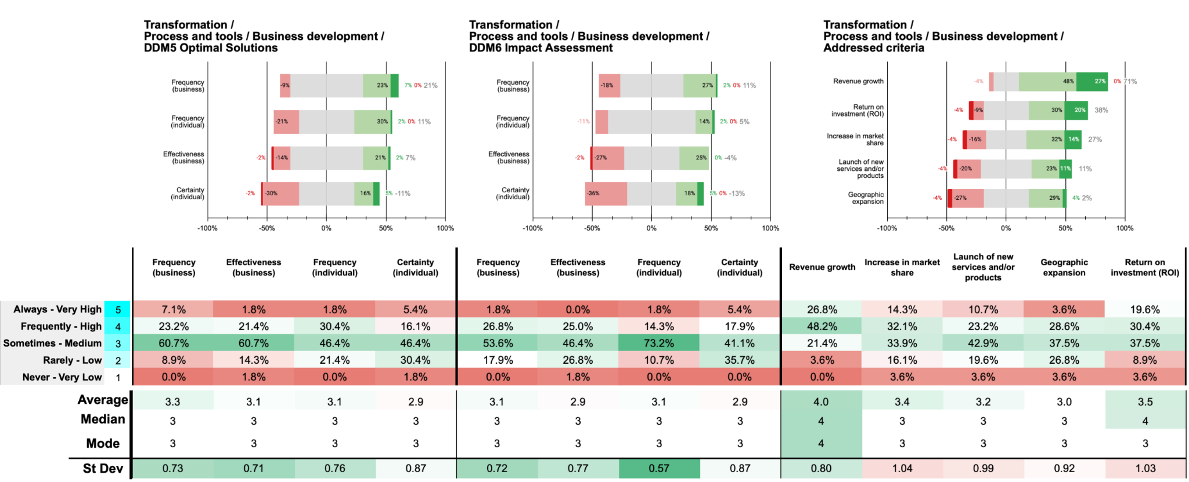

Organisational engagement in developing optimal solutions and action plans for business development processes during the transformation stage is moderate. Only 30.3% of participants report that their organisations *always* or *frequently* engage in this activity (7.1% *always*, 23.2% *frequently*). Individual participation is slightly higher at 32.2%. However, perceived organisational effectiveness is low, with only 23.2% rating it as *high* or *very high*. Individual certainty is modest at 21.5%, suggesting limited confidence among employees in these initiatives.

Engagement increases slightly when evaluating and monitoring the performance of business development practices, with 28.6% indicating their organisations *always* or *frequently* undertake this activity (1.8% *always*, 26.8% *frequently*). Individual participation is higher at 16.1% *always* and 14.3% *frequently*, totalling 30.4%. Perceived organisational effectiveness remains low at 26.8%, and individual certainty is moderate at 23.3%. This indicates that while some evaluation occurs, these practices may not be sufficiently systematic or prioritised within organisations.

The most prioritised criterion is Revenue Growth, with 75% of participants indicating their organisations *always* or *frequently* address it (26.8% *always*, 48.2% *frequently*). Return on Investment (ROI) follows at 50% (*always* 19.6%, *frequently* 30.4%). Increase in Market Share and Launch of New Services and/or Products are less emphasised, addressed by 46.4% and 33.9% respectively. Geographic Expansion is the least prioritised, with only 32.2% addressing it *always* or *frequently*.

During this stage, organisations demonstrate moderate engagement in developing optimal business development solutions and in evaluating performance against customer acquisition objectives. However, low perceived effectiveness and individual certainty highlight areas for improvement. The emphasis on revenue growth and ROI indicates a focus on immediate financial outcomes over innovation and expansion initiatives.

**Main findings / insights:**

1. **Moderate Engagement in Solution Development**: Only 30.3% of organisations always or frequently engage in developing solutions and action plans for business development during transformation, with individual participation slightly higher at 32.2%. Organisational effectiveness is low at 23.2%, and individual certainty is 21.5%.
2. **Limited Evaluation and Monitoring Practices**: Engagement in evaluating and monitoring business development performance is also moderate, with 28.6% organisational participation and 30.4% individual participation. Organisational effectiveness is low (26.8%), and individual certainty is moderate at 23.3%.
3. **Focus on Revenue Growth and ROI**: The top priorities are Revenue Growth (75%) and ROI (50%). Market Share (46.4%), Launch of New Services (33.9%), and Geographic Expansion (32.2%) are less emphasised, suggesting a focus on financial outcomes over expansion or innovation.

## 19 C Transformation / P3.2 Process + Innovation / DM5 - DM6

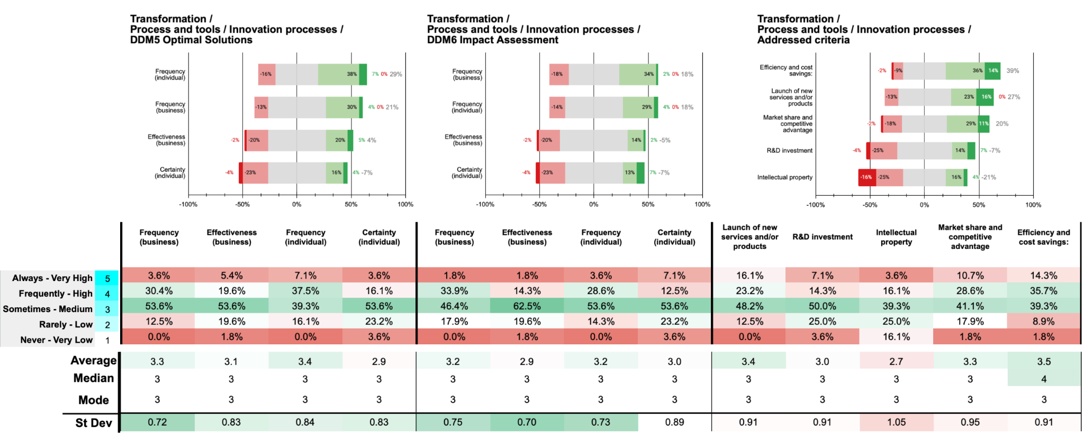

In the transformation stage, engagement in developing optimal solutions and action plans to adapt innovation processes is moderate. Organisational frequency is marked by 34% reporting high engagement (3.6% *always*, 30.4% *frequently*), while individual participation reflects slightly higher involvement at 44.6% (7.1% *always*, 37.5% *frequently*). However, effectiveness ratings remain relatively low, with only 25% rating these efforts as effective, indicating room for improvement in both process adaptation and confidence levels.

Monitoring and evaluating the performance of innovation processes for customer acquisition also shows moderate levels of engagement, with 35.7% indicating frequent or consistent evaluation (1.8% *always*, 33.9% *frequently*). Individual involvement in these evaluations is slightly higher at 40%, though organisational effectiveness remains low at 17.9%. Certainty levels among individuals are moderate, suggesting an opportunity to strengthen both the systematic evaluation of innovation processes and individual confidence in their outcomes.

In the transformation stage, the highest-priority criterion is Efficiency and Cost Savings, with 50% of participants indicating their organisations address this criterion *always* or *frequently* (14.3% *always*, 35.7% *frequently*). This is followed by Market Share and Competitive Advantage, prioritised by 39.3% of respondents at high or very high levels (10.7% *always*, 28.6% *frequently*). R&D Investment is also emphasised, with 21.4% of participants citing it as frequently or very frequently addressed. Launch of New Services and/or Products sees moderate focus, with 39.3% indicating consistent attention (16.1% *always*, 23.2% *frequently*), while Intellectual Property garners the least attention, with only 19.7% prioritising it at high or very high levels.

These findings indicate a strong organisational focus on Efficiency and Cost Savings alongside Market Share and Competitive Advantage during the transformation phase, reflecting a primary orientation towards operational performance and market competitiveness. The moderate attention to R&D Investment and Launch of New Services suggests selective innovation initiatives, while the low prioritisation of Intellectual Property indicates that organisations may be less invested in protecting long-term innovations. This pattern underscores a strategy favouring rapid adaptation and immediate market gains, with relatively less emphasis on intellectual asset development.

**Main findings / insights:**

1. **Moderate Engagement in Solution Development for Innovation**: Only 34% of organisations always or frequently develop solutions to adapt innovation processes, with individual participation at 44.6%. However, organisational effectiveness is low (25%), suggesting room for improvement.
2. **Monitoring and Evaluation of Innovation Performance**: Engagement in evaluating innovation processes is also moderate, with 35.7% indicating frequent or consistent evaluation. Individual participation is slightly higher at 40%, yet organisational effectiveness remains low at 17.9%, indicating a need for systematic evaluation practices.
3. **Prioritisation of Efficiency and Market Competitiveness**: Efficiency and Cost Savings is the most prioritised criterion, addressed frequently by 50% of organisations, followed by Market Share and Competitive Advantage (39.3%). R&D Investment and Launch of New Services are moderately prioritised, while Intellectual Property receives the least focus (19.7%).

## 20 C Transformation / P3.3 Process + Tools / Use of tools

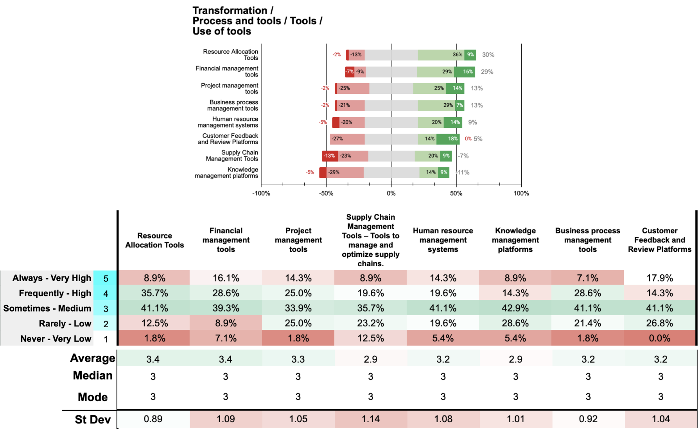

In the transformation stage, the prioritisation of tools reflects an organisational focus on adaptability and efficiency. Financial Management Tools have the highest engagement, with 44.7% of respondents rating their usage as *always* or *frequently* (16.1% *always*, 28.6% *frequently*). Resource Allocation Tools and Project Management Tools and also see substantial engagement, with 44.6% and 39.3% of organisations using these tools consistently.

However, Human Resource Management Systems, Customer Feedback and Review Platforms, Supply Chain Management and appear less frequently prioritised, with only around 34%, 32.2% and 28% of respondents indicating frequent or very high use. These patterns suggest a focus on managing internal projects and financial resources more than supply chain optimisation during transformation. Knowledge Management Tools show relatively low prioritisation, with only 23.2% of organisations rating their use as high or very high (8.9% very high, 14.3% frequently). This suggests that capturing and sharing organisational knowledge may be a secondary focus in the transformation stage.

In the transformation stage, tool prioritisation reflects an organisational focus on adaptability and efficiency. *Resource Allocation Tools* and *Financial Management Tools* lead in engagement, with 44.6% and 44.7% of respondents reporting frequent use (35.7% and 28.6% frequently, 8.9% and 16.1% always, respectively). *Project Management Tools* follow, with 39.3% frequent use, indicating their importance for managing transformation initiatives. *Business Process Management Tools* show moderate engagement at 35.7%, supporting efficient internal operations. *Human Resource Management Systems* and *Customer Feedback and Review Platforms* see lower prioritisation, with usage levels around 28% and 32.2%, respectively, highlighting secondary focus areas. *Supply Chain Management Tools* and *Knowledge Management Platforms* rank lower, with net negative prioritisation balances of -7% and -11%, respectively. *Resource Allocation Tools* show the highest positive balance at 30% followed closely by *Financial Management Tools* at 29%. This distribution suggests a strategic focus on tools that optimise financial and resource management, with a moderate emphasis on project and process efficiency. The relatively lower prioritisation of broader management tools, such as supply chain and knowledge platforms, may imply potential areas to explore for strengthening competitive advantage and innovation.

**Main findings / insights:**

1. **High Priority for Financial and Resource Tools**: Financial Management Tools and Resource Allocation Tools lead in frequent use, with 44.7% and 44.6% of participants indicating high or very high engagement. This prioritisation aligns with a focus on optimising financial and resource allocation during transformation.
2. **Moderate Use of Project and Business Process Management Tools**: Project Management Tools show substantial engagement, with 39.3% frequent use, supporting project execution during transformation. Business Process Management Tools follow closely at 35.7%, underscoring their role in process efficiency.
3. **Lower Prioritisation of Broader Management Tools**: Tools like Human Resource Management Systems and Customer Feedback Platforms have lower engagement, with only around 32% and 28% respectively. Knowledge Management Platforms see even less frequent use (23.2%), indicating they are secondary priorities during transformation.
4. **Focus on Efficiency over Broad Supply Chain and Knowledge Integration**: Supply Chain Management and Knowledge Management Tools show the lowest prioritisation, suggesting a lesser emphasis on external supply chain coordination and knowledge sharing within organisations during the transformation stage.

## 21 C Transformation / P4.1 People + Management / DM5 - DM6

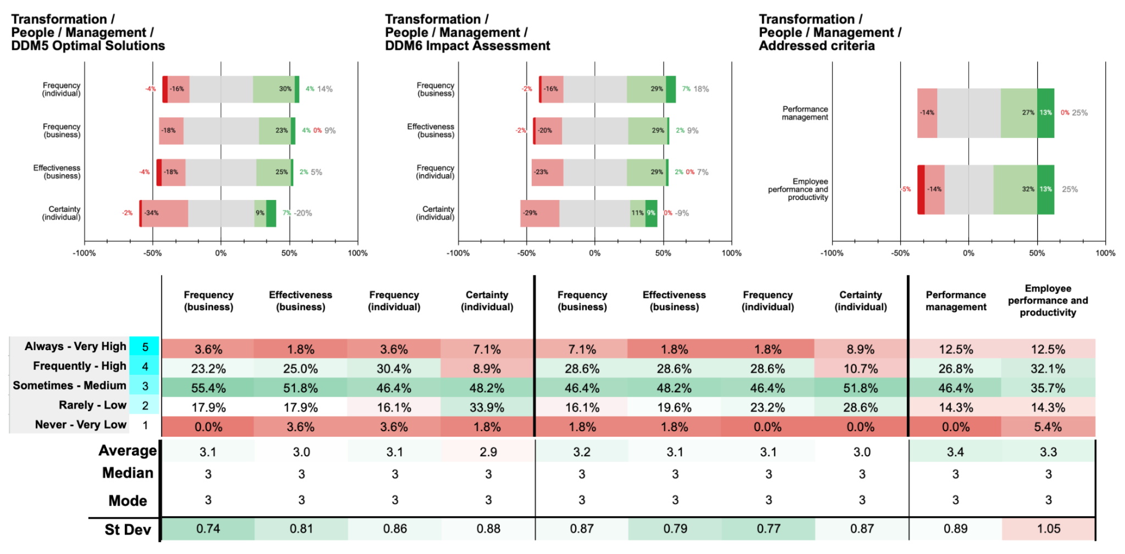

In the transformation stage, organisational engagement in developing optimal management solutions aimed at customer acquisition shows moderate levels. Only 26.8% of respondents indicate that their organisations frequently or always engage in this activity (3.6% always, 23.2% frequently), suggesting limited prioritisation of strategic management reconfiguration. However, individual involvement is slightly higher, with 34% of respondents participating actively (3.6% always, 30.4% frequently), indicating that while individuals are involved, organisational consistency may be lacking. Effectiveness in implementing these optimal solutions remains challenging, with just 26.8% of respondents rating organisational effectiveness as high or very high (1.8% very high, 25% high). Certainty levels reflect a similar trend; only 16% of respondents report high confidence in management's ability to develop these solutions, pointing to potential uncertainty or lack of structure in supporting these practices effectively.

When evaluating and monitoring management performance aligned with customer acquisition, engagement levels show some consistency, with 35.7% indicating frequent or very high activity (7.1% always, 28.6% frequently). However, effectiveness and certainty in monitoring management practices are moderate, suggesting limited systematic approaches. This implies that while performance evaluation is undertaken, it may lack the rigour needed for strategic impact.

For addressed criteria, the primary focus appears to be on *Performance Management*, with a combined 39.3% of respondents engaging in this activity always or frequently (12.5% always, 26.8% frequently). *Employee Performance and Productivity* follow closely, with 44.6% of respondents indicating frequent or very high engagement (12.5% always, 32.1% frequently). Despite these efforts, the moderate levels of effectiveness and certainty observed suggest that, while organisations recognise the importance of managing performance and productivity in alignment with customer acquisition objectives, the impact may be limited by a lack of consistent application and structured feedback mechanisms. Overall, organisations in the transformation stage display moderate engagement with management optimisation practices, but low effectiveness and certainty suggest room for improvement.

**Main findings / insights:**

1. **Moderate Organisational Engagement in Management Solutions**: Only 26.8% of organisations frequently develop management solutions for customer acquisition, while individual participation is slightly higher at 34%, suggesting a need for more consistent organisational prioritisation.
2. **Focus on Monitoring Performance, but Effectiveness Remains Moderate**: Although 35.7% of organisations frequently evaluate management performance related to customer acquisition, effectiveness and confidence in these practices remain modest, indicating potential gaps in systematic evaluation.
3. **Emphasis on Performance Management and Productivity**: Organisations primarily focus on Performance Management (39.3%) and Employee Productivity (44.6%), but moderate effectiveness and certainty levels imply that these initiatives may lack structured support, limiting their strategic impact.

## 

## Analysis of the Transformation Stage in Organisational Innovation



**Engagement in Reassessing and Adjusting Business Development Priorities**

The data reveals a moderate level of organisational engagement in reassessing and adjusting business development priorities to enhance customer acquisition in response to market changes. Specifically, only 17.9% of participants report that their organisations consistently engage in developing optimal business development solutions (P1.1 Performance + Business Development / DM5 - DM6). Individual participation is marginally higher at 32.1%, suggesting a slight disparity between organisational directives and individual involvement. The perceived organisational effectiveness in these activities is notably low, with merely 14.3% of respondents rating it as high or very high. Concurrently, individual certainty remains modest at 23.2%, indicating a lack of confidence among employees regarding their roles in these strategic adjustments.

Conversely, in evaluating and monitoring business development performance against customer acquisition objectives, engagement is somewhat more pronounced. Approximately 33.9% of participants indicate that their organisations frequently engage in these evaluative practices, with individual participation at 26.8%. However, perceived organisational effectiveness remains tepid at 19.6%, and individual certainty stands at 25.0%. This suggests that while some evaluative measures are in place, their impact and the confidence in these processes are limited, potentially undermining the efficacy of business development strategies.

The prioritisation of criteria during the transformation stage underscores a pronounced focus on revenue growth (87.5%) and return on investment (ROI) (69.6%), juxtaposed with less emphasis on increasing market share (51.8%) and launching new services or products (39.3%). Geographic expansion is the least prioritised, addressed by only 37.5% of organisations. This distribution indicates a strategic inclination towards immediate financial outcomes, potentially at the expense of broader market expansion and innovation initiatives. Such a focus may constrain long-term strategic adaptability and the ability to capitalise on emerging market opportunities.

**Engagement in Innovation Enhancements**

In the realm of innovation (P1.2 Performance + Innovation / DM5 - DM6), organisational engagement in developing optimal innovation solutions and action plans for customer acquisition is moderate, with 23.2% of participants reporting frequent or consistent involvement. Individual participation is slightly elevated at 28.6%, yet perceived organisational effectiveness remains dishearteningly low at 16.1%, accompanied by a modest individual certainty of 26.8%. These figures suggest that while there is some engagement in innovation-related activities, the effectiveness and confidence in these initiatives are significantly lacking.

When evaluating and monitoring innovation performance against customer acquisition objectives, 23.2% of organisations report frequent engagement, with individual participation at 28.6%. Perceived organisational effectiveness remains minimal at 16.1%, and individual certainty is consistent at 26.8%. This indicates that innovation performance assessments are sporadic and lack the necessary rigor to drive meaningful improvements.

The prioritisation criteria within innovation enhancements reveal a dominant focus on efficiency and cost savings (46.5%) and market share and competitive advantage (41.1%), while investment in research and development (R&D) and intellectual property (IP) receive scant attention, each at 16.1%. Launching new services or products garners moderate prioritisation at 32.1%. This pattern suggests a strategic emphasis on operational efficiencies and maintaining competitive positioning, rather than fostering long-term innovation through substantial investments in R&D and IP. Such an approach may inhibit the organisation’s capacity for sustained innovation and adaptability in a rapidly evolving market landscape.

**Value Proposition Development and Adaptation**

Organisational engagement in developing optimal value proposition solutions and action plans for customer acquisition during the transformation stage is moderate, with 34% of participants indicating frequent or consistent involvement (P2.1 Offer + Value Proposal / DM5 - DM6). Individual participation is slightly higher at 41%, yet perceived organisational effectiveness is restrained at 25%, and individual certainty is modest at 21.4%. This suggests that while there is a recognition of the importance of value proposition refinement, the execution and confidence in these processes are suboptimal.

In evaluating and monitoring the performance of value propositions, 41% of organisations report frequent engagement, with individual participation at 33.9%. However, perceived organisational effectiveness is low at 19.6%, and individual certainty is similarly modest at 23.2%. These figures indicate that the mechanisms for assessing the impact of value propositions are not robust, potentially limiting the ability to adapt and optimise value offerings effectively.

The prioritisation criteria within value proposition development highlight a significant focus on understanding market relevance (42.9%) and improving customer understanding (37.5%), alongside enhancing value communication (37.5%). In contrast, differentiators are less emphasised (28.5%). This allocation of focus suggests that organisations are attuned to aligning their value propositions with market trends and customer needs, yet may underinvest in distinguishing their offerings through unique selling points. This imbalance could impede the ability to effectively differentiate in competitive markets, thereby affecting customer acquisition and retention.

**Process Improvement in Business Development and Innovation**

Engagement in developing optimal solutions and action plans for business development processes during the transformation stage is moderate, with 30.3% of participants reporting frequent or consistent involvement (P3.1 Process + Business Development / DM5 - DM6). Individual participation stands at 32.2%, yet perceived organisational effectiveness is marginal at 23.2%, and individual certainty is similarly modest at 21.5%. These statistics suggest that process optimisation efforts are not deeply embedded within organisational practices, potentially limiting their impact on customer acquisition.

In evaluating and monitoring business development practices, 28.6% of organisations report frequent engagement, with individual participation at 16.1%. Perceived organisational effectiveness is slightly higher at 26.8%, and individual certainty is modest at 23.3%. This indicates that while some evaluative practices are in place, their effectiveness and the confidence in these processes remain inadequate, potentially hindering continuous improvement efforts.

The prioritisation criteria within business development process improvements show a dominant focus on revenue growth (75%) and ROI (50%), followed by an increase in market share (46.4%) and the launch of new services or products (33.9%). Geographic expansion is the least prioritised criterion, addressed by 32.2% of organisations. This emphasis on immediate financial metrics over strategic innovations and market expansions may restrict the organisation’s ability to adapt to changing market conditions and capitalise on new opportunities.

In the domain of innovation processes (P3.2 Process + Innovation / DM5 - DM6), organisational engagement in developing optimal solutions and action plans is similarly moderate, with 34% of participants reporting frequent involvement. Individual participation is higher at 44.6%, yet perceived organisational effectiveness is disappointingly low at 25%, and individual certainty remains modest at 21.4%. Engagement in evaluating and monitoring innovation performance against customer acquisition objectives is reported by 35.7% of organisations, with individual participation at 40%. However, organisational effectiveness is negligible at 17.9%, and individual certainty is modest at 26.8%.

Prioritisation within innovation processes underscores a focus on efficiency and cost savings (50%) and market share and competitive advantage (39.3%), with less emphasis on R&D investment (21.4%), launch of new services or products (39.3%), and intellectual property (21.4%). This distribution indicates a strategic preference for operational efficiencies and market positioning over long-term innovation drivers, potentially constraining the organisation’s capacity for sustained innovation and adaptability.

**Utilisation of Tools During the Transformation Stage**

The utilisation of tools during the transformation stage reflects organisational priorities towards adaptability, resource optimisation, and continuous improvement. Financial Management Tools exhibit the highest engagement, with 44.7% of organisations reporting frequent use (16.1% always, 28.6% frequently), closely followed by Resource Allocation Tools at 44.6% and Project Management Tools at 39.3%. These tools are essential for effective resource management and the seamless execution of transformation initiatives.

Conversely, tools such as Human Resource Management Systems, Customer Feedback and Review Platforms, and Supply Chain Management Tools demonstrate lower prioritisation, with utilisation rates of approximately 34%, 32.2%, and 28% respectively. Knowledge Management Platforms and Business Process Management Tools are less frequently prioritised, with only 23.2% of organisations reporting high or very high utilisation (8.9% very high, 14.3% frequently). This suggests that while there is a robust focus on financial and project management tools, broader management tools that facilitate knowledge sharing and supply chain optimisation are underutilised.

The strategic focus on Resource Allocation and Financial Management Tools indicates an emphasis on optimising internal resources and financial performance. However, the lower utilisation of knowledge management and supply chain tools may impede the organisation’s ability to leverage collective knowledge and optimise operational workflows, thereby limiting overall transformation effectiveness.

**Management Practices and Employee Confidence**

Management practices during the transformation stage reveal a moderate level of engagement in developing optimal management solutions aimed at customer acquisition, with 26.8% of participants reporting frequent involvement (P4.1 People + Management / DM5 - DM6). Individual participation is higher at 34%, yet perceived organisational effectiveness is modest at 26.8%, and individual certainty is low at 16%. This suggests that while there is some effort towards enhancing management practices, the impact is limited by low effectiveness and confidence levels.

In evaluating and monitoring management performance aligned with customer acquisition objectives, 35.7% of organisations report frequent engagement, with individual participation at 32.1%. Perceived organisational effectiveness is still low at 19.6%, and individual certainty is similarly modest at 25%. These figures indicate that while there is recognition of the importance of aligning management practices with customer acquisition objectives, the execution and confidence in these practices are insufficient.

The prioritisation criteria within management practices indicate a substantial focus on performance management (39.3%) and employee performance and productivity (44.6%). This suggests that organisations prioritise individual performance metrics over systemic performance management processes. While emphasising employee productivity is crucial, the relative neglect of comprehensive performance management systems may hinder the organisation’s ability to align individual contributions with broader strategic objectives, thereby limiting the overall effectiveness of transformation initiatives.

**General Findings**

1. **Strategic Emphasis on Immediate Financial Outcomes:** Organisations exhibit a pronounced focus on revenue growth and ROI during the transformation stage, often at the expense of long-term innovation and market expansion. This short-term financial orientation may constrain strategic adaptability and hinder the pursuit of sustainable competitive advantages.
2. **Low Perceived Effectiveness and Individual Certainty:** Across various activities, perceived organisational effectiveness and individual certainty remain consistently low. This indicates systemic deficiencies in the implementation and execution of transformation strategies, as well as a lack of confidence among employees regarding their roles in these processes.
3. **Moderate Engagement with Process Optimisation and Management Practices:** While there is a moderate level of engagement in process optimisation and management practices, the effectiveness and confidence in these activities are limited. This suggests that organisations may lack robust frameworks, adequate resources, or effective communication strategies to fully leverage these practices.
4. **Underutilisation of Comprehensive Management and Knowledge Tools:** The limited utilisation of tools such as Human Resource Management Systems and Knowledge Management Platforms suggests that organisations may not be fully leveraging technological solutions to enhance knowledge sharing, operational efficiency, and strategic management.
5. **Focus on Operational Efficiencies Over Innovation Drivers:** The prioritisation of efficiency and cost savings over foundational innovation drivers like R&D and intellectual property indicates a conservative strategic approach. This may impede the organisation’s capacity for breakthrough innovations and long-term value creation.
6. **Inadequate Alignment of Management Practices with Strategic Objectives:** The emphasis on individual performance over systemic performance management may result in misalignment between employee contributions and organisational strategic goals, thereby limiting the overall effectiveness of transformation initiatives.

**Conclusion**

The analysis of the transformation stage delineates a landscape where organisations demonstrate moderate engagement in strategic activities aimed at realigning business development, innovation, and value propositions in response to evolving market dynamics. However, this engagement is consistently undermined by low perceived effectiveness and individual certainty, highlighting systemic deficiencies in execution, communication, and resource allocation. The predominant focus on immediate financial metrics, such as revenue growth and ROI, at the expense of long-term innovation and market expansion, poses significant constraints on strategic adaptability and sustained competitiveness.

Furthermore, the underutilisation of comprehensive management and knowledge tools, coupled with a strategic emphasis on operational efficiencies over innovation drivers, suggests potential areas for strategic realignment. The challenges in management practices, characterised by a focus on individual performance metrics rather than holistic performance management systems, further compound the limitations in effectively leveraging transformation strategies.

# **Analysis of Organisational Innovation Across Five Levels**

Understanding how innovation operates within organisations requires a multifaceted approach that delves into various dimensions of organisational processes and capabilities. The Integrated Five-Level Model for Understanding Organisational Innovation provides a comprehensive framework that encompasses dynamic capabilities stages, innovation elements, sub-elements, dynamic capabilities substages, and key variables of frequency, effectiveness, and certainty (FEC). This analysis examines each level of the model, utilising data from study to uncover insights into how organisations engage with innovation practices and where potential gaps may exist.



### Level 1: Dynamic Capabilities Stages

At the foundational level, the model adopts David Teece's dynamic capabilities framework, which consists of three critical stages: Sensing, Seizing, and Transformation. These stages represent the organisation's ability to integrate, build, and reconfigure internal and external competencies to address rapidly changing environments.

In the **Sensing** stage, organisations are expected to identify and assess opportunities and threats in the business environment. The data reveals that a majority of participants perceive their organisations as frequently or always engaging in key sensing activities. For instance, 57.2% of participants believe their organisation always or frequently undertakes activities related to identifying and understanding problems or opportunities (DDM1) in business development. Similarly, in innovation performance, 44.6% of participants report that their organisations always or frequently identify innovation problems to boost customer acquisition. This indicates a considerable organisational commitment to recognising changes in the market and potential areas for innovation.

However, the **Seizing** stage shows a decrease in engagement and effectiveness. While organisations recognise opportunities, the data suggests challenges in mobilising resources to capture value from these opportunities. For example, only 32.2% of participants indicate that their organisations always or frequently collect data or evidence to support innovation improvements for customer acquisition. Moreover, perceived organisational effectiveness in identifying potential innovation solutions is modest, with only 23.2% rating it as high or very high. This suggests that although opportunities are identified, there may be deficiencies in developing and implementing strategies to seize them effectively.

In the **Transformation** stage, which involves the continuous renewal and reconfiguration of organisational assets, engagement levels are moderate to low. Only 17.9% of participants report that their organisations always or frequently develop optimal business development solutions for customer acquisition. Similarly, in innovation processes, only 23.2% of participants indicate that their organisations always or frequently develop optimal innovation solutions and action plans. This indicates a significant gap in the organisation's ability to adapt and transform to maintain a competitive advantage.

### 

### Level 2: 4P Business Parameters

The model's second level dissects innovation into four primary business parameters: **Performance, Proposition, Process & Tools, and People.**

**Performance** focuses on the outcomes of innovation activities. The data shows that organisations prioritise immediate financial metrics over long-term innovation. For instance, during the sensing stage, income growth is the most prioritised factor, with 87.5% of participants indicating that their organisations always or frequently address it when defining business development priorities. In contrast, the launch of new services and products is less prioritised, with only 53.5% addressing it. This suggests a focus on short-term financial outcomes rather than strategic innovation initiatives.

**Proposition** pertains to the value delivered to customers. Organisations demonstrate moderate engagement in identifying and adapting value propositions. During the sensing stage, 58.9% of participants indicate that their organisations always or frequently identify and define value propositions for customer acquisition. However, only 35.7% perceive their organisations' effectiveness in this area as high or very high. This gap suggests that while organisations recognise the importance of value propositions, they may struggle with effectively developing or communicating them.

**Process & Tools** encompasses the methodologies and instruments employed in innovation. The data indicates limited adoption of advanced tools. For example, only 17.9% report very high or high use of predictive analysis tools, and 14.3% for data mining tools. Organisations appear to prioritise tools offering immediate market insights over sophisticated analytical capabilities, potentially limiting their ability to leverage data-driven innovation strategies.

**People** focuses on individuals and teams executing innovation processes. The data reveals moderate engagement and low perceived effectiveness in management practices. In the sensing stage, only 28.6% perceive their organisations' effectiveness in identifying management needs as high or very high. Additionally, individual certainty is low, with just 17.9% feeling a high level of confidence. This suggests potential issues with leadership, communication, or resource allocation impacting the human element of innovation.

### Level 3: 4P Business Sub-parameters

Each innovation business parameter is further divided into sub-parameters, allowing for a granular analysis.

Within **Performance**, the sub-parameters are **Business Development** and **Innovation**. In business development, organisations show strong emphasis on income growth and ROI but less on launching new products. For instance, during the seizing stage, 91.1% of participants indicate that income growth is always or frequently addressed, whereas only 48.2% prioritise launching new services or products. This indicates a preference for exploiting existing markets over exploring new ones.

In the **Innovation** sub-parameter, efficiency and cost savings are highly prioritised over R&D investment and intellectual property. Only 21.5% of participants indicate that R&D investment is always or frequently addressed during the seizing stage. This suggests a focus on incremental improvements rather than radical innovation, potentially hindering long-term competitiveness.

For **Proposition**, the sub-parameter is **Value Proposition**. Organisations recognise the importance of understanding customer needs, with 53.5% always or frequently addressing customer understanding during the seizing stage. However, only 30.4% prioritise differentiators (unique selling points), indicating a possible lack of focus on what sets their offerings apart in the market.

Under **Process & Tools**, sub-parameters include **Business Development Processes**, **Innovation Processes**, and **Use of Tools**. The data reveals moderate engagement in refining processes but low perceived effectiveness. For example, in the seizing stage, only 34% of participants report that their organisations always or frequently identify solutions to improve business development processes, with perceived effectiveness at 21.5%. The limited use of advanced tools further suggests inefficiencies in process optimisation.

In **People**, the sub-parameter is **Management**. The data indicates that management practices are not strongly aligned with innovation objectives. During the seizing stage, only 32.2% of participants report that their organisations always or frequently identify potential management solutions to boost customer acquisition. Low effectiveness and individual certainty suggest that management may not be effectively driving innovation initiatives.

**Level 4: Dynamic Decide Model Questions**

The model identifies specific substages and questions aligning with dynamic decide model stages, from DDM1 to DDM6.

In the **Sensing** stage (DDM1 and DDM2), organisations are actively identifying opportunities and setting objectives. However, effectiveness and individual certainty are relatively low. For example, in DDM1 for business development, only 32.2% rate their organisation's effectiveness as high or very high, and individual certainty is just 14.3%. This indicates that while activities are occurring, their execution may be lacking in quality or clarity.

During the **Seizing** stage (DDM3 and DDM4), the engagement in data collection and identification of solutions decreases. In DDM3 for innovation improvements, only 32.2% of participants indicate that their organisations always or frequently collect data. Perceived effectiveness is low, suggesting potential deficiencies in gathering and utilising information critical for seizing opportunities.

In the **Transformation** stage (DDM5 and DDM6), activities related to developing optimal solutions and assessing impact are minimally engaged. For instance, in DDM5 for business development, only 17.9% of participants report that their organisations always or frequently develop optimal solutions. This low engagement suggests significant room for improvement in the organisation's ability to adapt and transform in response to market dynamics.

### Level 5: Variables-Metrics FEC (Frequency, Effectiveness, Certainty)

The FEC variables provide insight into how often organisations and individuals engage in innovation activities (Frequency), how effective these activities are perceived to be (Effectiveness), and the level of confidence individuals have (Certainty).

**Frequency** data shows that individual participation often mirrors organisational engagement but sometimes exceeds it, particularly in the sensing stage. For example, in identifying value propositions, 57.1% of individuals always or frequently participate, slightly higher than the organisational engagement at 58.9%. This indicates a willingness among employees to engage in innovation activities, even if not fully supported at the organisational level.

**Effectiveness** is generally perceived as moderate to low across all levels. For instance, only 25% of participants rate their organisations' effectiveness in developing optimal value proposition solutions as high or very high during the transformation stage. This suggests that despite engagement, the outcomes of innovation activities may not meet expectations or achieve desired results.

**Certainty** levels are consistently low, indicating that individuals may lack confidence in their roles or in the innovation processes. For example, in the seizing stage for innovation improvements, only 23.2% of participants experience a high or very high level of certainty. This lack of confidence could stem from unclear objectives, inadequate communication, or insufficient training and resources.

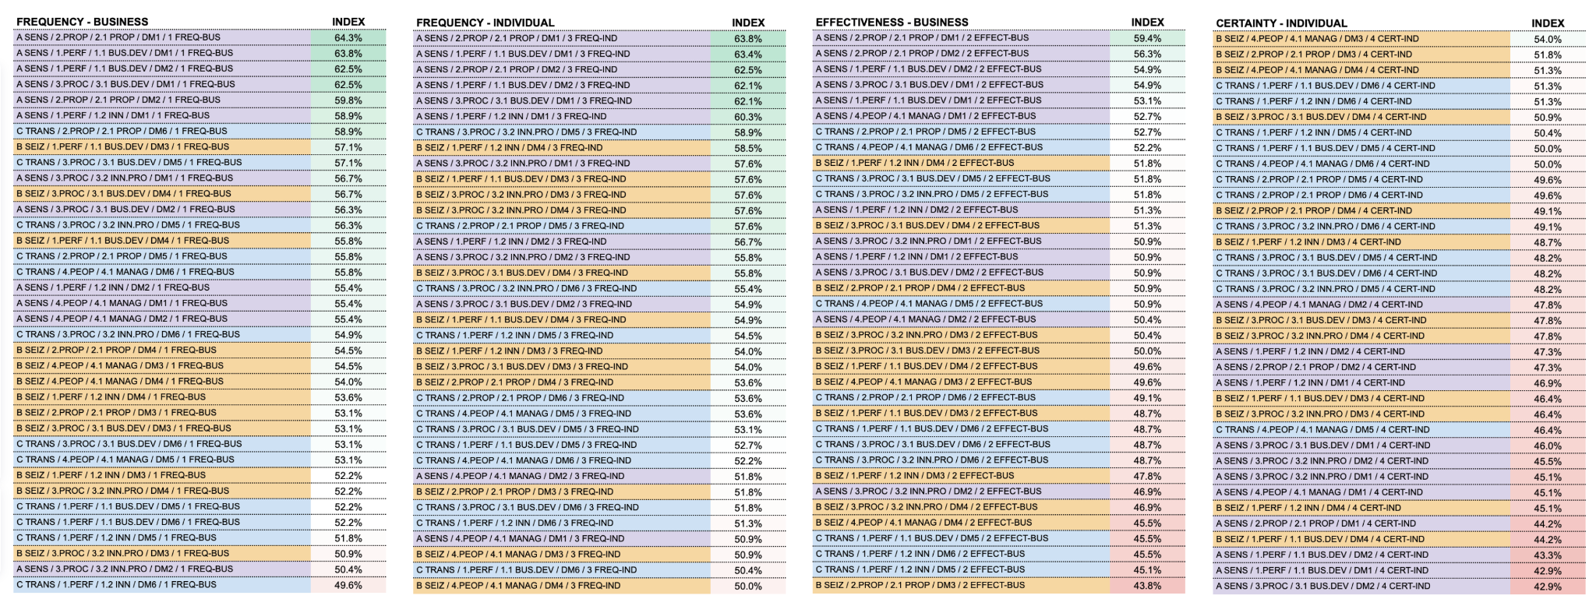



The perceived behaviour across the three stages of dynamic capabilities indicates a pattern where engagement frequency in innovation activities is initially high during the Sensing stage (58.4% in business frequency and 58.5% in individual frequency). This frequency then decreases slightly in the Seizing stage (54.0% for both) and remains relatively stable in the Transformation stage (54.2% in business frequency and 53.8% in individual frequency). Certainty exhibits an inverse trend, beginning with a lower perception in the Sensing stage (45.3%) and gradually increasing through Seizing (48.6%) and Transformation (49.4%), indicating a reduction in uncertainty as the stages progress. Perceived effectiveness, while following a similar pattern to frequency, demonstrates a more tempered progression: it starts at an intermediate level in Sensing (52.7%), declines in Seizing (48.8%), and stabilises in Transformation (49.2%). This suggests that although engagement levels are consistently perceived as high, organisational effectiveness is seen to decline during the Seizing stage, with little perceived recovery in the Transformation stage.

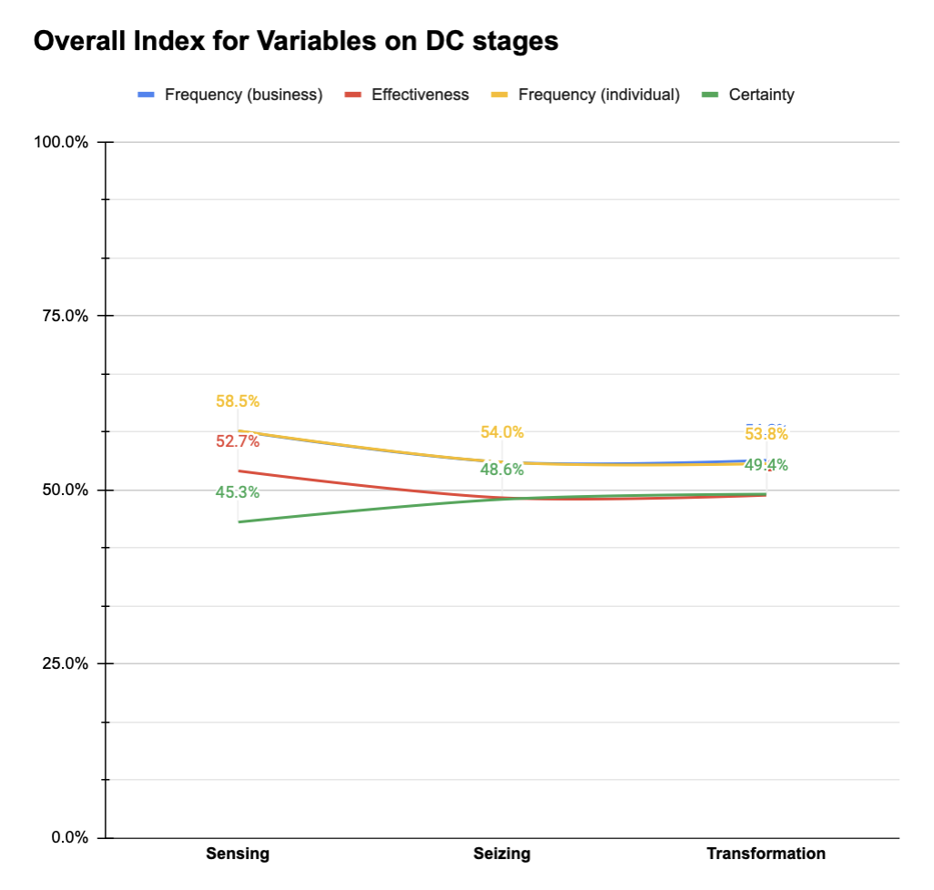

### General Findings

The analysis across all five levels of the model reveals several overarching themes:

1. **Focus on Short-Term Financial Metrics:** Organisations prioritise immediate financial outcomes, such as income growth and ROI, over long-term strategic innovation initiatives. This is evident in the high prioritisation of income growth (up to 91.1% during the seizing stage) and the lower emphasis on launching new products or investing in R&D.
2. **Limited Adoption of Advanced Tools:** There is a low utilisation of sophisticated analytical tools, such as predictive analysis and data mining. Organisations tend to favour tools that offer immediate market insights, potentially limiting their capacity for data-driven innovation and long-term strategic planning.
3. **Gap Between Engagement and Effectiveness:** While organisations and individuals are engaged in various innovation activities, perceived effectiveness and individual certainty are consistently low. This gap suggests potential deficiencies in execution, communication, or resource allocation that hinder the successful implementation of innovation initiatives.
4. **Underemphasis on Innovation Drivers:** Activities critical for fostering innovation, such as R&D investment, intellectual property development, and launching new products, receive less attention. This underemphasis may limit the organisation's ability to innovate and adapt in the long term.
5. **Challenges in Transformation Capabilities:** The low engagement and effectiveness in the transformation stage indicate that organisations struggle with adapting and reconfiguring their assets to maintain competitiveness. This may be due to a lack of strategic focus on transformation or insufficient resources dedicated to these activities.
6. **Human Capital and Management Issues:** Low levels of individual certainty and moderate engagement in management practices suggest that employees may not feel adequately supported or confident in their roles within the innovation process. Strengthening leadership, enhancing communication, and providing training could improve engagement and effectivenes

# **Analysis by Company Size**

Please check the charts and graphics on this link: <https://miro.com/app/board/uXjVLYaR9QY=/?share_link_id=874539402301>

Innovation is a critical driver of competitiveness and adaptability in today's dynamic market environment. Understanding how organisations of different sizes manage and execute innovation activities is essential for both academic research and practical application. The Integrated Five-Level Model offers a comprehensive framework to dissect the multifaceted nature of organisational innovation, encompassing dynamic capabilities (Level 1), innovation parameters (Level 2), sub-parameters (Level 3), decision-making stages (Level 4), and key variables such as frequency, effectiveness, and certainty (Level 5).

This report provides a comparative analysis of micro, small, medium, and large enterprises, aiming to identify patterns, strengths, and areas for improvement in their innovation practices and outcomes. By examining empirical data through the lens of the Integrated Five-Level Model, we gain nuanced insights into how organisational size influences innovation processes and performance.

**Level 1: Dynamic Capabilities Stages**

The dynamic capabilities framework, as posited by Teece, comprises three foundational stages: **Sensing** (A), **Seizing** (B), and **Transformation** (C). These stages represent critical phases in the innovation process, reflecting an organisation's ability to adapt and evolve in response to market changes.

**1. Sensing Stage (A)**

At this initial stage, organisations identify and assess opportunities and threats within their business environment.

* **Micro Enterprises**
* **Small Enterprises**
* **Medium Enterprises**
* **Large Enterprises**

**Insights**

Asdada dssadasd

**2. Seizing Stage (B)**

In the seizing stage, organisations mobilise resources to capitalise on identified opportunities.

* **Micro Enterprises**
* **Small Enterprises**
* **Medium Enterprises**
* **Large Enterprises**

**Insights**

Asdada dssadasd

**3. Transformation Stage (C)**

Transformation involves reconfiguring resources and processes to adapt to changing market conditions.

* **Micro Enterprises**
* **Small Enterprises**
* **Medium Enterprises**
* **Large Enterprises**

**Insights**

Asdada dssadasd

**Level 2: 4P Innovation Business Parameters**

The innovation activities can be further analysed through the 4P parameters:

* **P1: Performance**
* **P2: Proposition**
* **P3: Process & Tools**
* **P4: People**

**1. Performance (P1)**

Under the performance parameter, we assess the outcomes of innovation activities, focusing on business development (P1.1) and innovation (P1.2) sub-parameters.

* **Micro Enterprises**
* **Small Enterprises**
* **Medium Enterprises**
* **Large Enterprises**

**Insights**

Asdada dssadasd

**2. Proposition (P2)**

The proposition parameter examines the value offered to customers through the organisation's offerings (P2.1).

* **Micro Enterprises**
* **Small Enterprises**
* **Medium Enterprises**
* **Large Enterprises**

**Insights**

Asdada dssadasd

**3. Process & Tools (P3)**

This parameter involves the methodologies, procedures, and instruments employed to facilitate innovation.

* **Micro Enterprises**
* **Small Enterprises**
* **Medium Enterprises**
* **Large Enterprises**

**Insights**

Asdada dssadasd

**4. People (P4)**

The people parameter focuses on the individuals and teams executing innovation processes, particularly management practices (P4.1).

* **Micro Enterprises**
* **Small Enterprises**
* **Medium Enterprises**
* **Large Enterprises**

**Insights**

Asdada dssadasd

**Level 3: 4P Innovation Business Sub-parameters**

**1. Business Development and Innovation (P1.1 and P1.2)**

* **Opportunity Identification**
  + **Micro Enterprises**
  + **Small Enterprises**
  + **Medium Enterprises**
  + **Large Enterprises**

**Insights**

Asdada dssadasd

**2. Value Proposition (P2.1)**

* **Understanding Customer Needs**
  + **Micro Enterprises**
  + **Small Enterprises**
  + **Medium Enterprises**
  + **Large Enterprises**

**Insights**

Asdada dssadasd

**3. Processes and Tools (P3.1, P3.2, P3.3)**

* **Process Improvements**
  + **Micro Enterprises**
  + **Small Enterprises**
  + **Medium Enterprises**
  + **Large Enterprises**

**Insights**

Asdada dssadasd

**4. Management (P4.1)**

* **Setting Management Objectives**
  + **Micro Enterprises**
  + **Small Enterprises**
  + **Medium Enterprises**
  + **Large Enterprises**

**Insights**

Asdada dssadasd

**Level 4: Dynamic Decide Model Questions**

**1. DDM1: Identify and Understand Problems/Opportunities**

* **Micro Enterprises**
* **Small Enterprises**
* **Medium Enterprises**
* **Large Enterprises**

**Insights**

Asdada dssadasd

**2. DDM2: Establish Objectives and Priorities**

* **Micro Enterprises**
* **Small Enterprises**
* **Medium Enterprises**
* **Large Enterprises**

**Insights**

Asdada dssadasd

**3. DDM3 & DDM4: Data Collection and Deepening Understanding**

* **Data Collection**
  + **Micro Enterprises**
  + **Small Enterprises**
  + **Medium Enterprises**
  + **Large Enterprises**

**Insights**

Asdada dssadasd

**4. DDM5: Develop Optimal Solutions**

* **Micro Enterprises**
* **Small Enterprises**
* **Medium Enterprises**
* **Large Enterprises**

**Insights**

Asdada dssadasd

**5. DDM6: Evaluate and Monitor Impact**

* **Micro Enterprises**
* **Small Enterprises**
* **Medium Enterprises**
* **Large Enterprises**

**Insights**

Asdada dssadasd

**Level 5: Variables FEC (Frequency, Effectiveness, Certainty)**

**1. Frequency (FQB and FQI)**

* **Micro Enterprises**
* **Small Enterprises**
* **Medium Enterprises**
* **Large Enterprises**

**Insights**

Asdada dssadasd

**2. Effectiveness (E)**

* **Micro Enterprises**
* **Small Enterprises**
* **Medium Enterprises**
* **Large Enterprises**

**Insights**

Asdada dssadasd

**3. Certainty (C)**

* **Micro Enterprises**
* **Small Enterprises**
* **Medium Enterprises**
* **Large Enterprises**

**Insights**

Asdada dssadasd

**Overall Findings and Insights**

The comparative analysis reveals several key themes:

**Comparative Analysis Highlights**

**Concluding Remarks**

sdfsdfsd